CL/BSCSD/19/82 / st20171735

Mohammed Niaz Mohammed Inzamam

**Advanced Student Information System with Student Guiding and Recommendation and Results Prediction System for Greendale College to Enhance Student Performance**

# **Abstract**

Advanced Student Information System with Student Guiding and Recommendation and Results Prediction System for Greendale College is a web based system for the education that can be used to managed student information and data. This system is designed for Greendale College it would help administrators, manage student’s data more efficiently it would also help students to do their university course works within a less time and more easily.

Students Management System consists of two modules including administrators and students Profile. By this system has functions like Student Exam Results, Comment Reply and SMS notification. Administrators can use this system to register information of student and managing student’s profile and all the student details. Students can view results courses assignments and payment details through this system

This system has functions to recommend how student must work to improve their results and guiding them in their coursework and predict student upcoming results. This system uses student past results for their course modules to give recommendations and predict future results for their course work in the college. This system can benefit to administrators and students they will able to carry out their daily educational and university activities more efficiently and accurately.

Contents

**Abstract** 2

**Chapter 1** 3

**Introduction** 3

Background of the problem 4

Problem Statement 4

Solution 5

Literature Review 6

Project Objectives 9

Project Scope 10

Functionalities and Non-Functionalities of the system 10

Admins main functionalities 11

Admins main functionalities 12

Non-functional requirements 13

ProjectLimitations 13

Work Breakdown Structure 15

Cost Plan 16

Chapter 2 17

BACKGROUND OF THE STUDY 17

Current System Explanation 17

Drawbacks of the Current System 18

Explanation of the Proposed System 18

Chapter 3 20

FEASIBILITY STUDY AND REQUIREMENT GATHERING 20

FEASIBILITY STUDY 20

3.1.1 OPERATIONAL FEASIBILITY 20

3.1.2 TECHNICAL FEASIBILITY 20

3.1.3 ECONOMICAL FEASIBILITY 21

3.1.4 LEGAL FEASIBILITY 21

REQUIREMENT GATHERING 22

Conclusion 24

SECONDARY REQUIREMENTS 25

Performance Requirements 25

Safety Requirements 25

Security Requirements 25

Software Quality Attributes 26

DESIGN OVERVIEW 26

Resource identification 27

Chapter 3 28

Methodology and the Design of the proposed system 28

4Methodology 28

Facts Finding Techniques 29

Quantitative Data Analysis 31

Selected development methodology – SSADM (structured systems analysis and design method) 32

Structured Systems Analysis & Design Method Techniques 33

SSADM uses a combination of the three methods: 33

Software Development Life Cycle (SDLC) 34

Waterfall model 35

Sequential phases in waterfall model according to the project 36

Design 38

Database 38

Entity relationship diagram – ER diagram 39

ER Diagram 39

Normalized Relational Schema 40

Context level diagram 42

42

Level 1 Diagram for the proposed system 43

43

Deliverables and expected outcomes 44

Chapter 05 45

Project Infrastructure 45

5.1 Project Infrastructure 45

Chapter 06 46

User Interface 46

Wireframes 59

79

80

Chapter 7 80

SYSTEM TESTING 80

7.1 Testing Scope and Overview 81

7.2 White Box Testing 81

7.3 Grey Box Testing 82

7.4 Black Box Testing 82

The Differences between the testing methodologies 83

7.5 Testing Approach 83

7.2 Test Plan & Cases 84

Users Test Plan 84

Test cases 92

Chapter 09 188

Risk Analysis 188

9.1 Risk Management Plan 188

9.3 Risk Analysis 188

Chapter 10 189

Summary 189

10.1 Solution Evaluation 189

References 189

# 

# Chapter 1

# Introduction

Technology is widely used in present and people are used to live with it. However, some web applications are too old to run parallel with todays. Colleges and education have also evolved in recent years. Primary schools, like universities and high schools, require their particular administration systems. Greendale College's current management system, on the other hand, has already been classified as an old generation management system, and it is unable to meet the needs of its users.

As an outcome, the Greendale College Student Management Application will be implemented as an improvement to the existing system or to supplant the manual system in order to overcome the problems that were encountered whenever the old system or manual system was in use. Greendale College's advanced student information system with student guiding and suggestion system is a software application for education which manages student data and information.

The system is designed to be web-based, which means that the user can utilize it without having to browse the web. This system's users are divided into two categories: students plus administrators. Administrators' responsibilities include reading, writing, and editing. Administrators may effortlessly manage any student information and data using this system, and students can quickly understand their progress.

Aside from that, this system incorporated new technology for automatically give recommendations and Guides for students and predict student’s future results using their past result to improve their college course work. In order to do that system use students past result for each subjects and system will automatically give recommendations and prediction of upcoming subject results to improve student’s results in exams and assignments in their course work.

The proposed program will take the place of Greendale College's existing system, and it will undoubtedly enhance the college's student management system and work quality.

# Background of the problem

# Problem Statement

The use of a manual approach to manage pupils, in which all data is held in a journal or even on paperwork, has made the administrator's job harder. Whenever an accident occurs, the records in the system may be lost or destroyed. While the institution now uses computers to maintain student data, many of the systems in use have been old. They all utilize stand-alone systems that solely perform single purpose. That made it more difficult for administrators to use all of the systems at the same time. Separate systems that are not connected to one other lead the identical information and data to be keyed in in each system. Aside from that, the system in use lacks a result prediction component as well as a student suggestion and guidance mechanism. This could result in the student receiving lower grades on subsequent assignments and tests, as well as a lack of motivation for university education and work. Furthermore, the approach used does not provide a predictive feature for the outcome. As a result, the student will receive poor grades on subsequent assignments and tests.

## 

## Solution

Introducing full-automated Advanced Student Information System for Greendale College with Student Guiding and Recommendation and Result Prediction System to Enhance Students Performance. The administration will be able to conduct their work more easily using this approach. Students at all levels have varied additional functionality throughout this student management system. Students could use the system to download and submit assignments, check their fees and grades, file complaints, and receive university reminders and alerts. Administrators can use the system to manage all of the student and admin information, as well as store student information and data.

Students were frightened when they failed the test or their marks fallen, and their grades dropped, result in a failure their subjects. However, by using new function to predict future performance of the students encourages them to work hard in order to enhance productivity, as well as students can see their success. Each student's learning abilities vary; a few are strong, while others are weak. As a result, the outcomes are distinctive. As student if they got recommendations to for their results students also try hard to make themselves to study to improve their results according to the recommendation they got via the system. This recommendation system will make student motivate for their course work and make good performance in their grades.

## Literature Review

Experts are striving to solve the problem of analyzing and predicting student results. A decision tree-based classification strategy to predict students' final test outcomes has been presented in Mining Educational Data to Analyze Students Performance. According to the authors, the stored data in educational databases may play a critical role in the improvement of students' performance. (B. K. Bhardwaj, S. Pal, 2011)

Ralph, Buskirk, and Schmidt (2007) carried out a study on the use of web-based projects among students for online activities, and found that the lecturer's accessibility for fast and easy responses was an enormous help. Moreover, the study discovered that when people utilize technology, they talk about the money they'll have to pay on it, their capacity to utilize the web, and the new technologies' trustworthiness. Investigation of student focuses and satisfaction with online courses provides information and insight regarding student replies and satisfaction with the executions of an online examination.. (Hale, 2007)

Educational data mining and its applications to anticipate the much more successful environment for learning is a research study by Lewis Adam Whitley. This researcher may try to take data from the University of North Carolina at Pembroke in this study project and turn it into external influences which might or might not affect a student's learning abilities. The author determined the most effective strategy for locating an educational environment and attempting to identify characteristics that may influence a student's academic success. (Whitley, 2018)

Professor Krithi and Doctor M Ramakrishna claims that in International Research Journal of Computer Science in 2017 about this (SIRS) in this Student Information Report System (SIRS) the system has come up with many variabilities for educational institutions to keep track on the improvement of students and managing attendance. It favors both student and parents to keep track of student progress without travelling to the educational institute. Also it alerts students and parents to crucial college events. Another feature is the parent will be notified when the student is failed in the exam. The student information that is being collected is as follows; registration number, DOB, Students’ sex, Guardians contact number, residential address, guardian name. All these data that has been entered will be stored in the database. The Student Information Report System is a very convenient method for all educational institutes, schools, colleges and etc. It is adaptable to the requirements of the client. This could be employed both in the business and public sectors. SIRS is a web-based program that allows us to gain access almost anywhere in the world where there is internet access and service. The document explains how to conduct the productivity, administration, and decision-making functions of businesses or organizations. When there is rapid increment in the student enrolments and etc., it will be a very hard task to save all the student details manually and also there is a risk of losing of the student data when it is done manually (paper based). So by using this system, it automates everything and is very easy to use. The student’s data can be retrieved within a fraction of a second since, all the data is being stored in the database. To address these issues, we developed a new student information management system with extra capabilities. The new method will allow for quick processing, accurate student tracking, and the desired outcome. Students will be able to preserve their personal information using this method. It's much more safe, dependable, and simple to be using. (Ramakrishna, 2020)

Because users generally judge the total system's object depends on their happiness with those services, access to services is at the heart of any system's performance. Nearly every single online student management system provides a wide range of features to satisfy the requirements and aspirations of its users. According to Maere (2011), the SMS is responsible for student administration, which involves enrollment, examination records, evaluation process, finance, room assignment, transcripts, students union electronic voting, mobile text messaging, and examination results reviews. As a result, it is likely that online student management systems will be developed in-house at most institutions of higher learning to aid in student registration, online profiling, financial recording, examination grade records, transcript production, student housing management, and maintaining student records. As a result, it is likely that online student management systems will be developed in-house at most institutions of higher learning to aid in student registration, online profiling, financial recording, examination grade records, transcript production, student housing management, and maintaining student records. (LUBANGA, 2017)

Patterson also conducted a poll in 2006 to see how students were completing their tests online. He has arrived to the conclusion that the majority of students were likely to participate in virtual assessment methods as a result of his research. According to the comments he received, 87 percent of respondents believe that using tests online is far better in the long term, Patterson also discovered that the fulfillment of the online exam approach used allowed students to complete the test whenever and wherever they wanted, depending on personal preferences. And, as a result of his research, he has reached the conclusion that this way, rather than going via the documentation, decreases the applicants' anxiety.(patterson, 2020)

Data Mining Algorithms to Classify Students, Cristobal Romero ET. Al Students should be classified. To design a particular Moodle data mining tool, I collected real data from Cordoba University students in seven Moodle courses. The authors investigated several data mining strategies for classifying candidates based on their Moodle usage statistics and their final course grades. The researchers came to the conclusion that an educational decision-making classifier must be both broad and reliable. (C. Romero, S. Ventura, P. G. Espejo, C. Hervás, 2008).

## 

## Project Objectives

This project is mainly developed in order to solve the issues that students face in common, which are getting low marks and failing exams. Using the decision-making statements, this system is predicting the future results of the student and forecast the future outcomes of the student by looking to the students past results.

The system is using student results to build graphs, progress bars, and pie charts of student performance. As a result of this, administrator will be able to determine whether students' status, progress, or performance has improved as a result of their results. By this, the lecturer can identify the weak spot of the student and help them to achieve further good results.

The aim is to create a cutting-edge student management system that meets the client's requirements. We should identify the project's goals using SMART criteria.

Finally, the project is also able to improve the students time management through smart application features.

## Project Scope

The ultimate goal of this project is to create and design a system website for Greendale College to Enhance Student Performance that will allow them to easily track their students' exam and assignment results, grades, and payments for student success, among other things.

Our student management system can meet all of the Greendale College requirements. Both personal and academic information about the students will be held. This will also keep track of the students' fees. Management will be able to easily obtain data from each and every student who has previously studied at this university, and administration will be able to provide assignments, exams, and results through the system. The most significant aspect is that this device will automatically predict student future exam and assignment outcomes by analyzing past results and making decisions. Furthermore, admin can view their students' output using graphs, progress bars, and pie charts based on the outcomes of each module.

This system includes some algorithm called decision making algorithm, that’s the main part of the system which predicts students future results. This is a very big advantage for nowadays systems because non of the systems contain this kind of a function which predicts students future results.

## Functionalities and Non-Functionalities of the system

### Admins main functionalities

* Login
* administrator must login to the system first. he can login using by user name and password
* admin have to use the correct password incorrect username and he can login to system directly
* if administrator going to using the incorrect password and username he can see the error message on the top of screen.
* Register
* administrator cannot register the system. because he has a username and password in the database
* Enrol Students
* Admin can register students and also he can update the student’s records and details.
* Manage Users
* Admin can add users to the system also he can manage users details and he or she can update the user details also he can register a student to the system.
* Manage Profiles
* Admin can manage the user’s records and details.
* Manage Students
* Administrators should have permission to update the students results and student’s assignments marks and their details.
* Manage Courses
  + - administrator can add courses to the system and he can also update the course details and remove the courses from the systems
* Manage Fees
* administrator can update the course fee and another course fee to the system
* Manage Results
* administrator can and student’s assignments and exams results to the system and he can also update the student’s results
* Manage Assignments
* administrator can add assignment to the system and he can also remove the assignment from the system and update the assignment details
* Reply for Complains
* admin can view complaints and reply for it

### student main functionalities

* Login
* The username and pass word given by the admin.
* View future results predictions
* student can view their future results prediction in the system
* View Recommendations and Guiding
* system will be automatically send the guiding and Recommendation messages from the system
* View payments
* Students can view their payments information on the system
* View Results
* Students can view their Results information on the system
* Submit and download assignments
* students can download the assignments and view their assignments and also he can upload to upload their assignments to system
* Make Complains
  + student can make a complaint

### Non-functional requirements

* performance
* students can easily work with the systems because the system can manage lot of users at the same time.
* Security

## ProjectLimitations

• As this is a web-based system, the administrators and students would be unable to complete their tasks if the server is unavailable.

• If students or administrators do not have adequate hardware or access to the internet, they will cause a significant problem by employing this method, as all of their data will be destroyed.

• People who are new to this system or who are unfamiliar with computer hardware or software and how things operate will have a difficult time with it.

• If a large number of users begin working on the server at the same time, there may be a data lag and the software could collapse.

• Since all confidential material is maintained in the database, a very maximum security system is required in this system.

## Work Breakdown Structure

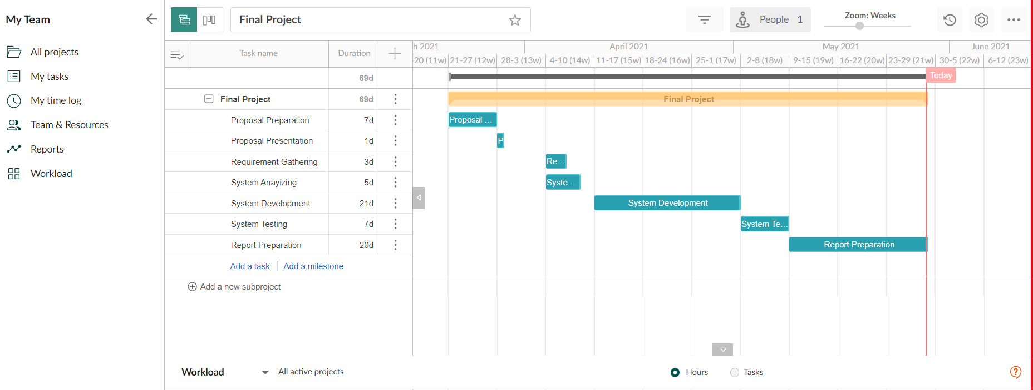

# Chapter 2

## BACKGROUND OF THE STUDY

## Current System Explanation

Currently, all information is handled manually by the Greendale College where staff in the university enters data to the staff university. Students, receive both assignment and send the assignment to the lecturer through email. Also, all the payments are done by the students where they go to the finance department of the university and complete the payment or the students can pay the fees to a particular bank and send the payment slip through email with their information to the university. Moreover, each and every student’s results are being sent through the email personally to every student. The enrollment of students is even done by filling details for a given paper by the university. Furthermore, all the details of the admin and the staff members of the university are managed by access database and computers. Even if any student is needing to request something or to make any complaint, he/she must go and meet coordinates in university. Above mentioned all details represent the current situation in the Greendale College

## Drawbacks of the Current System

It becomes increasingly difficult for staff members, administrators to handle all the records of the students through a manual system such as handling journals, papers and books. Paper records are much less reliable than digital files as data and information of private documents can fall into a wrong person’s hand or it might be lost, destroyed or stolen. While the university has long used computers to manage student records, each of the systems it employs are now obsolete. As employees use manual databases to process data, it takes a long time for them to retrieve a single piece of information from the database, which is time - consuming process. Manually processing and keeping all documents is not a secure practice. When data is duplicated, it may lead to errors in data management. It wastes a lot of time, which is a huge drawback for university day-to-day tasks. The very same information duplication is frequently generated by separate systems that are not connected to each other. Such manual method also has an impact on student academics because administration lack a proper way to instruct and monitor students, leading to low academic performance, which lead students to fail their exams and assignments. When using a paper work document, it is also more tough to create adjustments if they desire. The major drawback of the manual method is that it can quickly turn into a huge expense, causing the company to lose money by increasing these expenses.

# Explanation of the Proposed System

To address these issues, we created a fully integrated system for the Greendale College, which will enable administration to do their jobs more efficiently. Since introducing this student management system, the manual system of paper works can no longer be used at this university. All user levels in this student management framework have various new functionalities, including the admin, teachers, lecturers, and students. Students can use the system to download and view their grades, upload assignments, view their course information, display their fees, view their course modules, file complaints, view their assignments and tests and receive university notes and alerts. Administrators can monitor all of the student's data.

Also, admin can review students in various batches, student module results, module assignments, and students submitted assignments via this system, as well as make complaints, display alerts and notices sent from the university via the system, and so on.

Inability to pass the exam results in lower grades. Students are afraid, and low grades cause them to fail their subjects. But, by using decision making to anticipate future outcomes, students motivate themselves to work harder in order to better their performance, and students can therefore see their performance. Each learner's ability to learn is different, with some being excellent and others being bad.

admin will be able to see from the graphs and charts that there has been an improvement in the status, success, or performance of students using this new student’s performance function.

* If some data breach happens it may cause to major issues since in the backend, all the sensitive information is saved.

# Chapter 3

## FEASIBILITY STUDY AND REQUIREMENT GATHERING

## FEASIBILITY STUDY

# 3.1.1 OPERATIONAL FEASIBILITY

Operational feasibility is a measure of whether a suggested framework addresses problems and acts appropriately to address issues and act appropriately for the specified responsibilities. This really is contingent on HR being available for the project, and it involves predicting yet if the framework will be used if it is designed and implemented.

# 3.1.2 TECHNICAL FEASIBILITY

It's all about the specific and measured aspects when it comes to technological feasibility. The technical feasibility section covers all of the materials and technical forms that were used to put this system together. It delivers a high level of dependability, accessibility, and compatibility. The unique requirements are then compared to the association's specialized capabilities. If the internal specialized capability is sufficient to support the project requirements, the frameworks project is regarded feasible.

# 3.1.3 ECONOMICAL FEASIBILITY

If the usual benefits equal or exceed the usual expenditures, the framework can be determined to be financially feasible. Money saving advantage analysis is done in monetary achievability, where only predicted costs and benefits are analyzed. The viability of the proposed framework is assessed using monetary analysis. It does not necessitate any additional hardware or programming.

The financial plan for this framework is listed below. Furthermore, if the planned cost approaches or exceeds the advantages that are typical, it will be a financially feasible option.

# 3.1.4 LEGAL FEASIBILITY

Seeking consent from the police as well as other government high commissions in specified locations.

Legal viability determines if the proposed system conflicts with legal requirements. This type of requirement is frequently based on government regulations. The government will inspect the program until it is completed. Seeking consent from the police and other government high commissions in specified locations. This will examine what kind of features are there in the system, whether any of them are inappropriate, and whether the system complies with government regulations and limits. At the end of the day, this student management system should be registered with the state. Then no one else can build a website with the same name.

# REQUIREMENT GATHERING

To make this project more effective, we'll need the input of a third party so that we can improve the system as a result of their suggestions. Questionnaires, interviews, and other methods can be used to acquire the information needed. This system is proposed. My requirement gathering method was a questionnaire for the students on with regard to my project scope. The questionnaire that I have produced is as follows;

***1.What is the current way of maintaining the student details and data and how it helps you!?***

*………………………………………………………………………………………………………………………………………………………………………………………………………………………………………………………………………………………………………………………………………………………………………………………………………………………………………………………………*

#### **2.What problems do you see (students) in the current way of maintaining all the data??**

*………………………………………………………………………………………………………………………………………………………………………………………………………………………………………………………………………………………………………………………………………………………………………………………………………………………………………………………………*

***3. If the SIRS is being developed, how may it affect you on your privacy??***

*………………………………………………………………………………………………………………………………………………………………………………………………………………………………………………………………………………………………………………………………………………………………………………………………………………………………………………………………*

#### **4.What pros and cons do you (student)see in this particular SIRS system??**

*………………………………………………………………………………………………………………………………………………………………………………………………………………………………………………………………………………………………………………………………………………………………………………………………………………………………………………………………*

#### **5.How convenient would this SIRS system help out the parents / Guardians?**

*………………………………………………………………………………………………………………………………………………………………………………………………………………………………………………………………………………………………………………………………………………………………………………………………………………………………………………………………*

**6. What problems may cause on the parents / students, when using this system (Device unavailability etc.)?**

*………………………………………………………………………………………………………………………………………………………………………………………………………………………………………………………………………………………………………………………………………………………………………………………………………………………………………………………………*

**.7Given that this system is web-based, what challenges do you anticipate!?***………………………………………………………………………………………………………………………………………………………………………………………………………………………………………………………………………………………………………………………………………………………………………………………………………………………………………………………………*

#### **8. Sum up your ideas on which amendments, pros, cons should happen in order to fulfill our system, and all the questions on this system that runs through your mind after presenting about the proposed system!?**

*………………………………………………………………………………………………………………………………………………………………………………………………………………………………………………………………………………………………………………………………………………………………………………………………………………………………………………………………*

## Conclusion

Whenever we analyze the questionnaires and interviews, we find that the existing manual system isn't really providing the service that the university requires. We analyzed many other problems based on the client's requirements again from interview, and they think they can go with an automated system because of these concerns, which is what this new student management system could fix. Whenever it refers to questioners, the majority of employees choose a computerized, web-based, completely automated system with accessibility for all departments to arrange information and a sophisticated but full system. They need a system that is more safe and performs well. With all the information received, We're working on a system that has all of the necessary capabilities, and it's especially useful for academic departments because of the preferred outcome and process management features.

These would be the additional questions I included in my survey. It is simple for me to find out the advantages and disadvantages of the system and proceed appropriately with the assistance of a third feedback so which I can solve the challenges which have been raised by the students. This is a more helpful way for me to develop my system furthermore.

# SECONDARY REQUIREMENTS

### Performance Requirements

The following are some of the identified performance requirements:

A minimum of 10,000 student records should be able to be stored in the database. Multiple users should be able to utilize the software at the same time. There are no additional performance requirements that will have an impact on development.

### Safety Requirements

Caused by a virus or an operating system malfunction, the database could crash at any time. As a result, a backup of the database is required.

### Security Requirements

The following are some of the criteria that have been found to safeguard software from unintentional or malicious access, usage, modification, destruction, or disclosure. Keep a specified log or set of historical data.

* Assign certain functions to different modules
* Restrict communications between some areas of the program
* Check data integrity for critical variables

### Software Quality Attributes

The system's quality is maintained in such a way that it would be very user pleasant for all users.

* • Because it is an examination gateway, the system must be safe.
* • Up-to-date hardware and software are required for the system to work smoothly..
* • The system should be straightforward and easy to use.

## DESIGN OVERVIEW

The system process architecture is covered by the design summary. It simply refers to a structure that indicates the running process of a system from the start. In regards to my idea, the Greendale College sophisticated student information and recommendation framework, there is a clear direction for the running process.

When it comes to core functions, my project administrator is the one who is responsible for issuing student information around the entire campus, according to my project administrator. When an administrator publishes the results, students can access them by logging into their student portal. When the admin sends out the data, the outcome prediction page on the student portal calculates the average for all of the results and uses nested if else to make decision statements for the averages. After that, the device calculates the pass and fail rates for the students, after which the next module's result and average can be measured and shown in a pie chart for the students' convenience.

When the administrator issues the students' remarks, my second core role is also linked to the students' performance. Admins can access their portals and check all of their students' progress and results in the form of a pie chart by simply entering the student ID number. More than reviewing the students' usual result repost, pie charts and progress bars make it easy to assess their results.

## Resource identification

Specific hardware and software requirements should be included in the development of a system in order for the project to be successful. The following are the hardware and software requirements for developing an online examination system. The system's quality is maintained in such a way that it is very user pleasant for all users.

Hardware Requirements: -

* Intel Core i5 8th generation processor
* 8 GB RAM
* 1 TB ROM
* 64- bit operating system

Software Requirements: -

* Operating System: Windows 10
* Development Technology: PHP
* Front-End: HTML, CSS, JAVASCRIPT
* Back-End: phpMyAdmin
* Web Server: Google Chrome

These requirements are both applied to the client’s side and the server side.

# Chapter 3

## Methodology and the Design of the proposed system

### 4Methodology

When a new program is developed, before even software design, data must be investigated, analyzed, and then designed. There seem to be a number of steps to be completed before generating software. This is a set of actions that should be carried out in a specific order, almost like a model. As a result, a number of general models will be given by an amount of people. We've chosen such a role model from in them to help us improve our program. We chose the Water Fall Model to construct our system. More data on this model, as well as the rationale for its selection, may be found further down.

The waterfall model is the system development life cycle model that we are utilizing to construct our website, Greendale College Modern Student Management System, because we aim to create it in stages, following the steps of installation, troubleshooting, implementation, testing, design, and maintenance. Our major goal is to produce an error-free website by following this approach.

As a result, production is established at each level of the waterfall model, and the project manager is aware of the system's development, making it more efficient and dependable. Because of our limited funds, the method must be expense. Nonetheless, there are certain flaws in this concept. As though slight modifications might cause a major problem in any of the previous phases, which are all interdependent. This model carries a greater risk.

To acquire all of the criteria, we had to visit some private sector as well as government university student managements, such as ICBT Campus and Esoft Metro Campus, and meet program managers and coordinators, counsellors, and marketing managers at the Greendale College. We used the fact-gathering procedures listed below to acquire all of the requirements.

### Facts Finding Techniques

A developer often employs a variety of fact-gathering strategies throughout the course of a project. Below shows some methods used commonly.

* Researches
* Documentation Review
* Questionnaire survey
* Observing the company in motion
* Interviews

We choose Interviewing and Questionnaires as our method for finding facts for this project

#### Questionnaires

Survey questionnaires are among the most effective ways to get data from large number of people, including the context of student management. Users respond to the system analyst's queries by first filling in the question asked by the system analyst. As every user does not need to be questioned by a system analyst, a survey questionnaire can save time. Questionnaires are also more beneficial when interview period is limited. In order to meet the criteria of the system aim, the system analyst must be able to specify the design and layout of questionnaires.

There are two types of questionnaires:

#### Free-format questionnaires

In free-format questionnaires, users are allowed to answer questions freely without receiving an instant answer. The results are indeed useful in gaining insight into the participants' ideas, viewpoints, and experience. Qualitative data is the term used to describe those questionnaires.

#### Fixed-format questionnaires

Fixed-format questionnaires are designed to gather information from specified question formats. Users are given the option of selecting a response from a list of options. Multiple-choice (yes or no) questions, rating questions (strongly agree, agree, hardly any opinion, oppose, and disagree strongly), and ranking questions are the three main types of fixed-format questions. Quantitative data is a term used to describe these questionnaires.

#### Interviews

The much more extensively used tool for analyzing information obtained from face-to-face interviews. The meeting's objective is to evaluate, confirm, and present ideas, as well as to motivate end-users, establish requirements, and obtain feedback. An interviewer who is a system analyst and an interviewee who is the system's owner or user make up the interview team. Interviewing methodology incorporates excellent communication skills for connection between system analyst and consumer. There are two kinds of interviews.

#### Unstructured interviews

An encounter with a broad objective or topic in mind and very few, if any, specific questions. In unstructured interviews, open-ended questions are being used to allow users to react freely in a way that is appropriate. Qualitative data refers to the results of such interviews.

#### Structured interviews

A structured interview is one that consists of a predetermined set of questions. Close-ended questions are used in organized interviews to limit interviewee responses and establish judgments, short and straight responses. Quantitative data is another term for such interviews.

### Quantitative Data Analysis

We successfully analyzed quantitative data in accordance with the project. As a result, for the questioners, we must employ quantitative data analysis and interviews to obtain needs:

Quantitative data is easy to analyze in real-time contexts, and researchers acquire data for the quantitative assessment process, allowing analysis of the data to happen nearly quickly. Experiments, surveys, and interviews provide fast results from a data-driven strategy. Less time spent acquiring these resources makes it easier to spot connections that finally lead to a beneficial result.

When opinions are accepted as acceptable substitutes, anything is conceivable. Quantitative analysis eliminates this question since it only considers real-world data. The work is validated since, despite the presence of randomized conditions, the results still point to the very same data. Throughout time, minute differences can be uncovered, however the general assumptions made by researchers that use this approach stay valid.

Researchers can utilize the quantitative approach to focus on a topic they would like to study in the broad population. When a set of data points within a demographic are particularly valuable, this method is frequently used. A mechanism allows us to analyze the reasons for our decisions, behaviors, or actions from a social perspective.

## Selected development methodology – SSADM (structured systems analysis and design method)

Procedural programming is comparable to structured programming. It's also possible that it's a subclass of Procedural programming. It's used to improve the consistency and clarity of the programming language, resulting in more logical and readable program execution.

Structured programming languages employ structured control flow, which includes the structure of subroutines, iteration, selection, and sequence blocks, as well as the code of that programming language implemented according to the structure in which it was written, as you may have guessed from the name. Structured programming, like Procedural Programming, frequently employs a top-to-bottom technique, meaning that the code produced in Structured programming is executed in a sequential order from top to bottom, one after the other. Sequence, iteration, collection, and subroutines are all necessary components of programming for Organized Control Structure.

Advantages and disadvantages of structured programming

**Advantages of Structured Programming:**

1. Easier to read and understand
2. User Friendly
3. Easier to Maintain
4. Mainly problem based instead of being machine based
5. Development is less difficult because it takes less time and effort. Easier to Debug
6. Machine-Independent, mostly

## Structured Systems Analysis & Design Method Techniques

## SSADM uses a combination of the three methods:

#### Logical data modeling;

A logical data model (LDM) describes the concepts, relationships, and interpretations of data values. It's a logical data model since it doesn't specify the physical structures in which data can be stored in files or databases, or sent among service units.

#### Data flow modeling;

A data flow model is a diagrammatic description of how information flows and exchanges inside a system. Data flow models are being used to depict the flow of data in an information system graphically by detailing the procedures involved in transporting data from input to file storage and report production.

#### Entity behavior modeling;

The act of recognizing, modeling, and documenting the events that effect each entity, as well as the order in which they occur.

Every one of those three process model presents the same system from a different angle, and each point of view is required to form a complete model of the system in development. The three strategies are cross-referenced against each other to guarantee that the overall application is full and precise.

For this complex Student Management System, we must build the following diagrams: ER Diagram level 0, level 1, and, DFD Context as per the project.

### Software Development Life Cycle (SDLC)

The system project plan, often known as the System Development Life Cycle (SDLC), is split into six primary stages:

* Requirement Analysis
* Design
* Development
* Maintenance of system
* Testing
* The Software Development Life Cycle (SDLC) is a set of processes that start with a set of user requirements and end with a process that serves those criteria.
* The current tendency is to incorporate numerous checks throughout the SLDC to guarantee that the mistakes upon finishing is kept to a minimum.

This method, often known as the waterfall model or the linear period of the waterfall, is a logical explanation of the phases involved in the building of data systems. The meaning of the term "waterfall" will be described in the accompanying diagram.

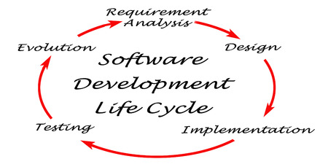

### Waterfall model

The waterfall model was the first process model to be presented. It is simple to comprehend and apply. The whole software project is divided into stages in this paradigm. The input for the next step is constantly influenced by the effects of the previous phase. This means that each level of development begins only after the previous one has been finished.

The following are the reasons why this design was chosen for the project.

Has a well-defined structure.

When contrast to other methods, Waterfall emphasizes a logical, well-defined sequence of phases. It has a simple structure.

2.Information is effectively transferred.

Waterfall is a methodical technique; therefore, it should make no difference that it promotes a clear transmission of information at each phase.

3. Early on, the eventual goal is determined.

Devoting to a final result, goal, or deliverable at the start is one of the defining elements of Waterfall, and teams should resist deviating from that commitment.

## Sequential phases in waterfall model according to the project

Requirement gathering and analysis- This marks the beginning of the waterfall's evolution. This step gathers all project specifications from users and captures and documents the system to b

e created. To get all of the requirements from the Greendale College, I'll need to employ questioners and a literary survey at this point.

System design- The needs acquired in the previous step are then used to create the program's software in this stage. I'm utilizing structured programming for this student management system. Prior to implementing the system, I must design and create all of the diagrams, Relational Schema, including the ER, Context, Level 0 and Level 1 Diagrammatic. An entity relationship diagram, also known as an entity relationship model, is a graphical depiction of a data structure. The Data Flow Diagram is a graphical representation of a system's data flow. By creating a Data Flow Diagram, you may describe the data provided by and given to someone who participates in system processes.

Implementation- As per the database and system architecture in the previous step, the system is initially developed with every function in little programs called units. To implement the student outcome prediction function, we use decision making statements like nested if otherwise, and to develop the lecturer user level key task, we apply decision making a statement like nested if otherwise.

Integration and testing- All units developed throughout the implementation process are included into a system after they have been tested. After integration, the entire system is thoroughly tested for any flaws or defects. Following the deployment of the student management system, I must perform testing for each system function; for this, I am employing manual testing with a test plan and test scenarios.

Development of system- When the functional and non-functional program is done, the device is implemented in the client setting or published into the Greendale College. As per this step, we must host this system, so we select a hosting plan such as Cloud Hosting, which allows many other virtual servers (clouds) to collaborate to host a website or a network of websites. This has limitless capacity to deal with traffic spikes. A cloud-hosted website is not tied to a single server, and the resources allocated to it will shrink or dynamically expand depending on how much traffic it receives. That is an excellent solution for huge websites, newsletters, such as e-commerce sites, and blogs. Once your web hosting has been acquired, we can obtain Name Servers (also known as Domain Name Servers or DNS), which are the Internet's version of a phone book holding IP numbers. Have your website up and running, we'll need to alter your domain name servers. You may now upload Greendale College Student Management System to the account using either cPanel's File Manager or an FTP client such as FileZilla by connecting to the server using either cPanel's File Manager or an FTP client such as FileZilla.

Maintenance- When there are issues that affect the system's users, maintenance is usually undertaken. A system update has been published to address these issues. In the last stage, we'll hand it over to the Greendale College University's IT department, along with a user manual, and they'll be in charge of maintaining the system going forward.

## Design

A software architect or designer can spot a design flaw that has already been addressed by another. A prototype or pattern that represents a solution to a common issue is referred to as a design pattern. Reusing techniques that have already been tested and proven will speed up the software development process. There are two types of design stages.

● Database Design

● Interface Design

## Database

The process of grouping the columns and tables of a relational database to avoid redundancy is known as database normalization. Splitting and detecting links between huge data into smaller, less repetitive tables is what normalization entails. The goal is to isolate data such that field additions, removals, and alterations can be done in a single table and then distributed throughout the database using defined linkages.

## Entity relationship diagram – ER diagram

The Entity Relationship Diagram is a diagram that depicts the relation between two entities. The Entity Relationship Model (ERD) is a visual representation of a data structure that describes the relationships between people, objects, places, ideas, and events inside that system. An Entity relationship diagram visualization framework that may be used to classify company categories and build up a social database.

### ER Diagram

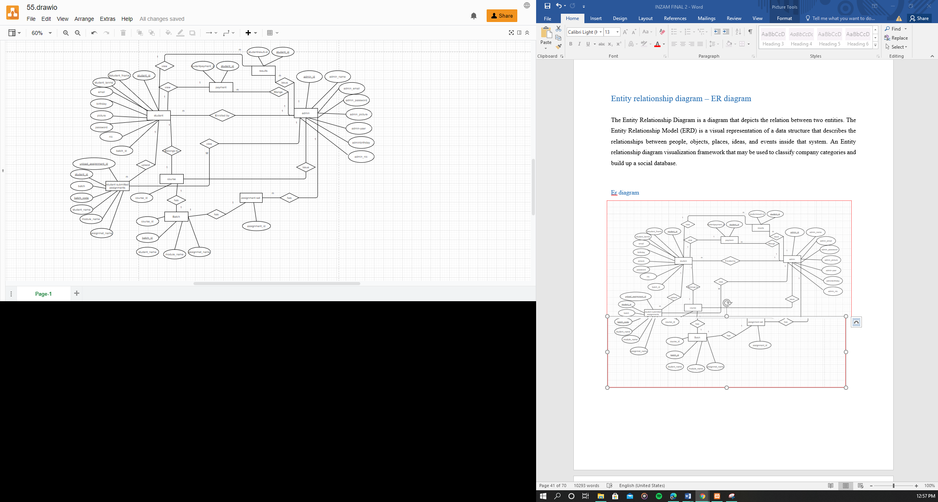

## Normalized Relational Schema

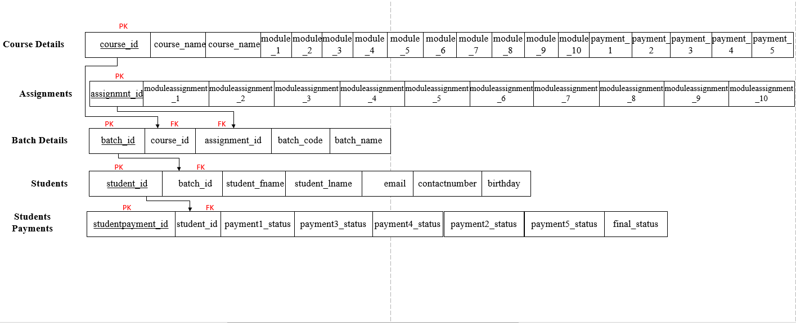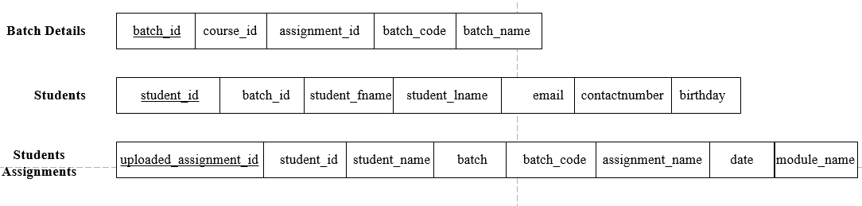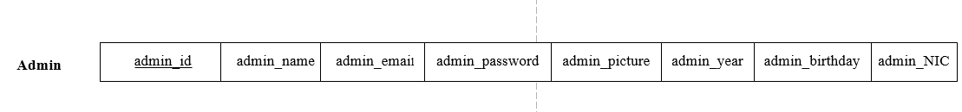

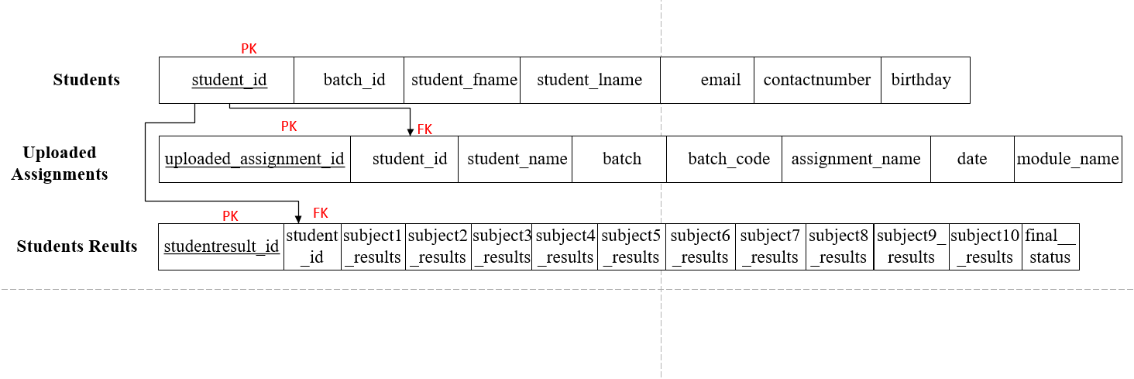

## Context level diagram

# 

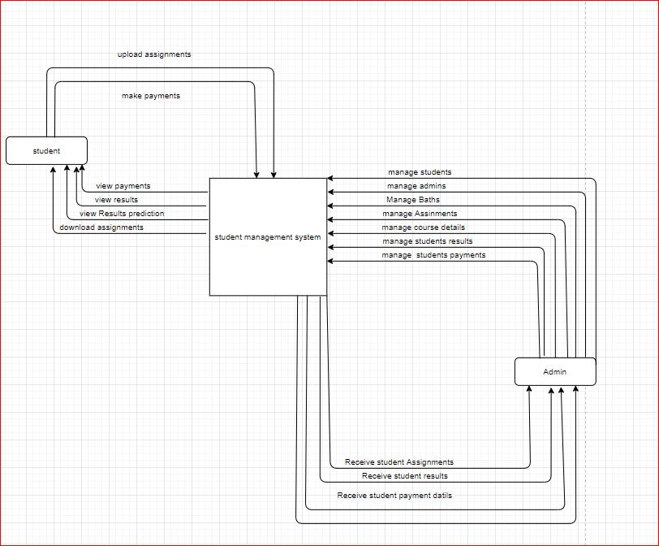

## Level 1 Diagram for the proposed system

# 

## Deliverables and expected outcomes

This study aims to develop a Advanced Student Information System with Student Guiding and Recommendation and Results Prediction System for Greendale College to Enhance Student Performance. This study has the following objectives;

* Software thesis;

Documentation of the method

User Manual.

* Documentation of project;

Explanation for the requirements in the program

Explanation for the software designing

Project management strategy of the implemented system

Quality checking plan program

Management strategy for device setup

Testing and the dry run of the software

Finalization of the system with the client requirements.

# Chapter 05

## Project Infrastructure

### 5.1 Project Infrastructure

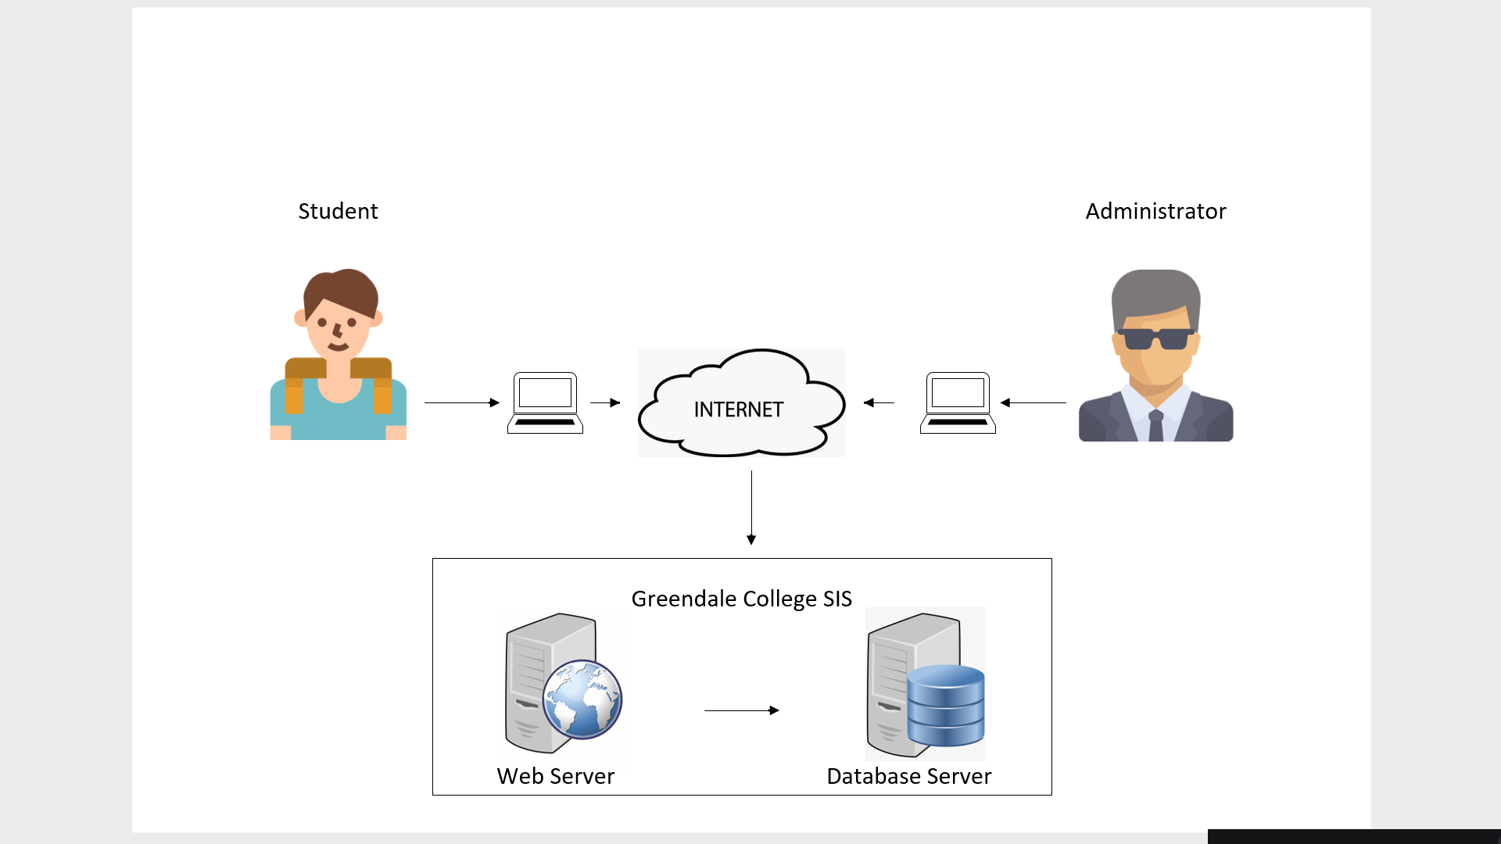

This system's project infrastructure is somewhat sophisticated. This system has three user levels: administrator and student. Each user can access the system over the web through their login information. The database is accessible to those three user levels. The database could only be managed by the administrator; additional user levels could only access the information in the database. Program managers, counselors, financial managers, marketing management and other administrators are among the users at the administrator level. Greendale college's system managers will be in charge of system maintenance.

# Chapter 06

### User Interface

The user interface (UI) is the point of interaction and communication among computers and humans in a program. Displaying screens, keyboards, a cursor, and the existence of a computer are all examples of this. Also it refers to how an user's interaction with a program or web. The growing focus of several organisations on web apps and mobile apps had driven several firms to place higher attention on UI in an effort to improve the overall user experience.

Good User Interfaces Have Many Benefits

1.Increased efficiency

2.Lower cost for development

3.Higher cost of customer service

4. Increased customer engagement and retention

5. Obtaining new customer

###### Admin login

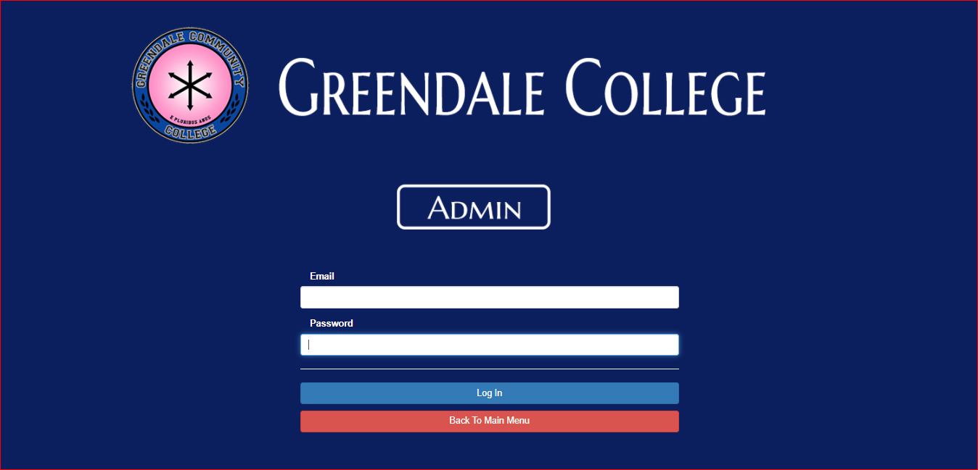

###### Admin Home



###### Admin Profile

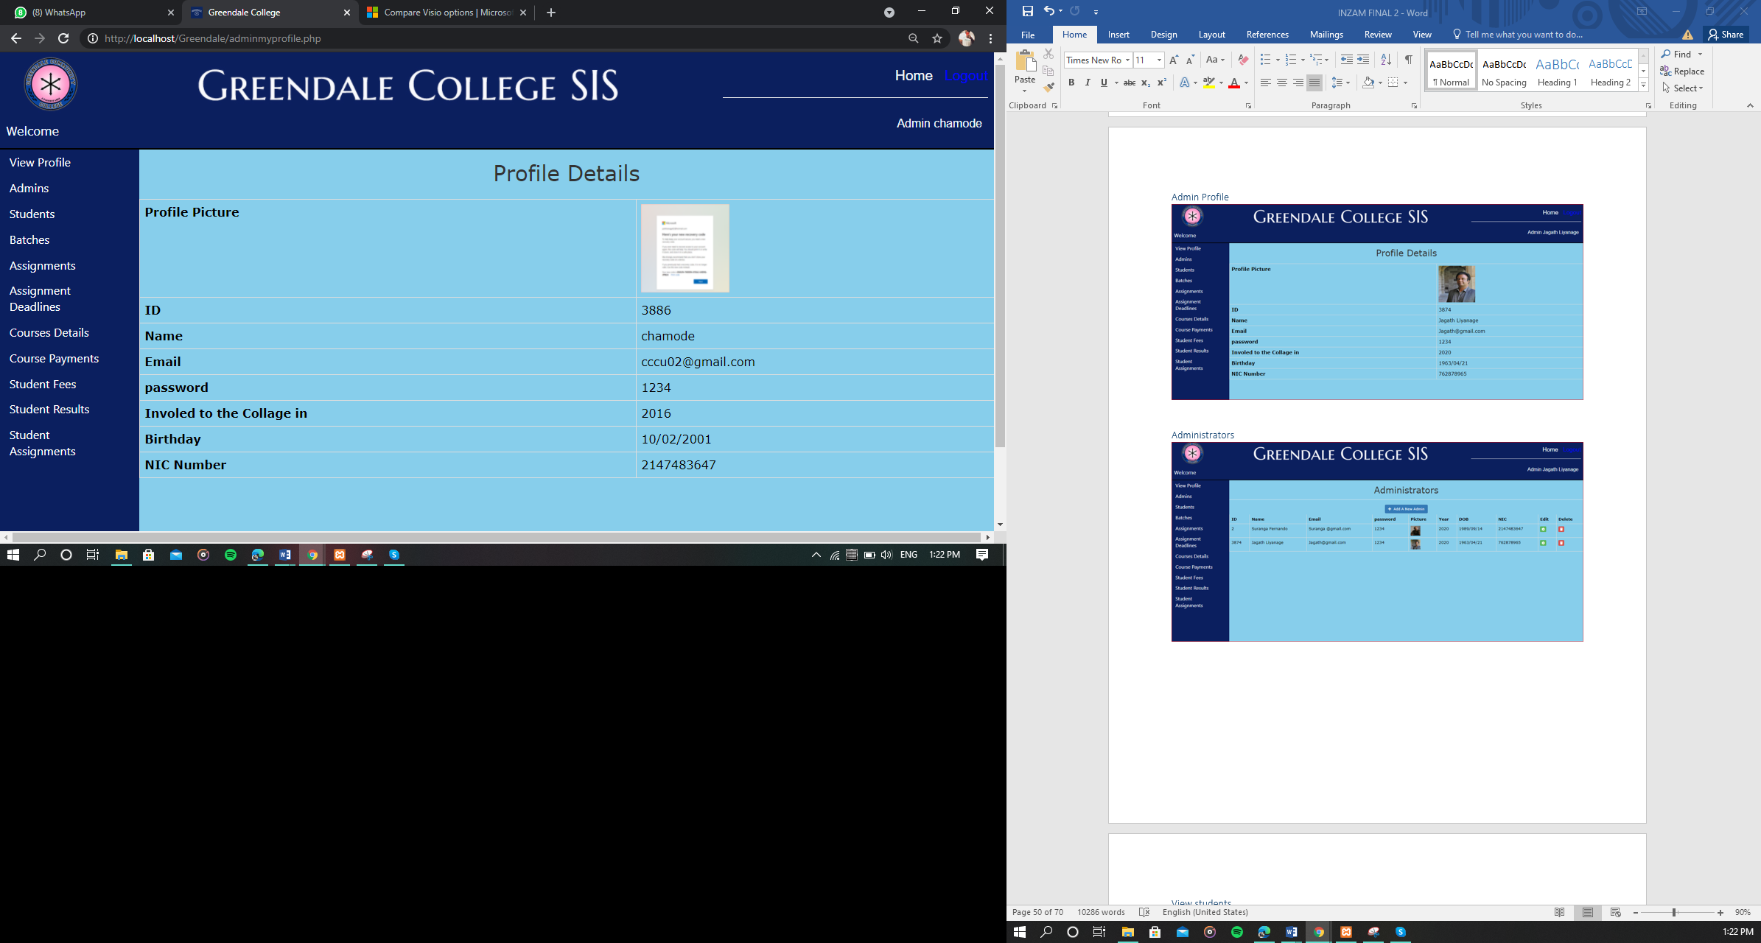

###### Administrators

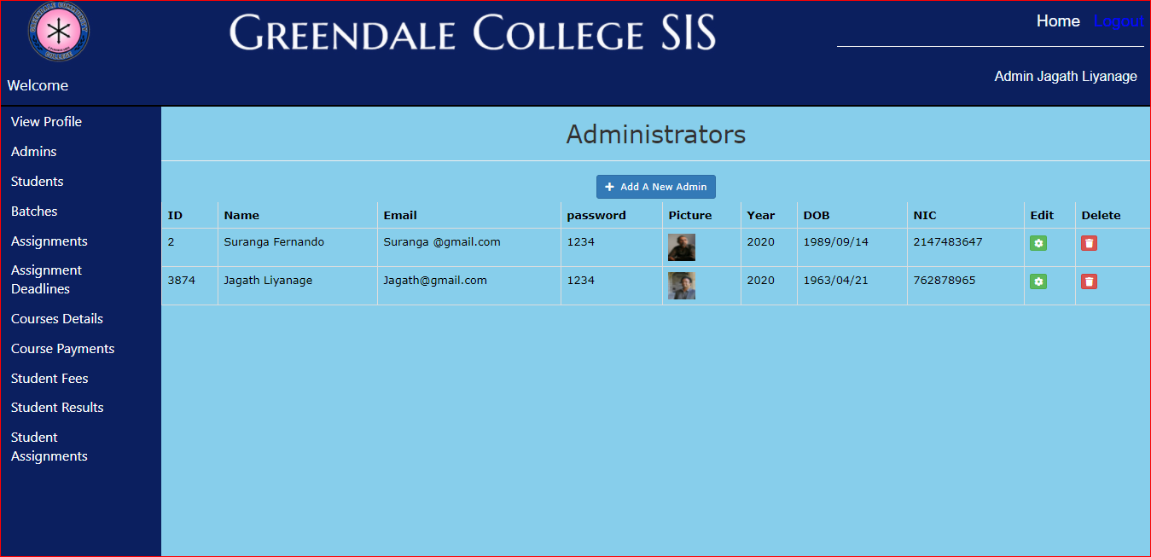

###### View students

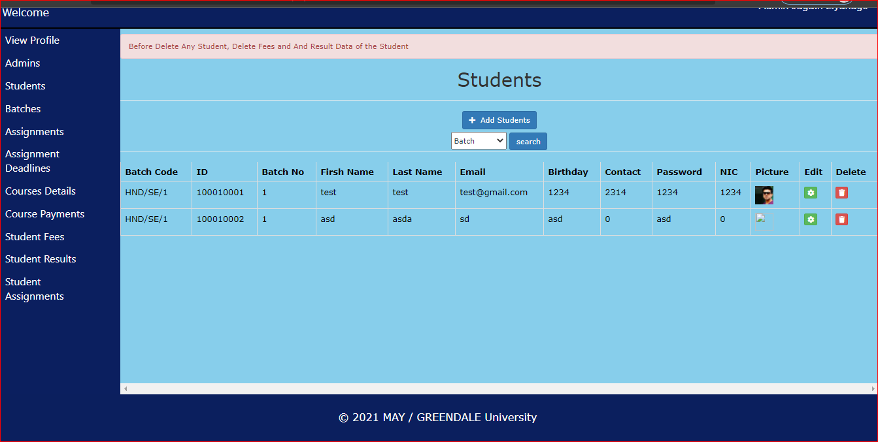

###### View bathes

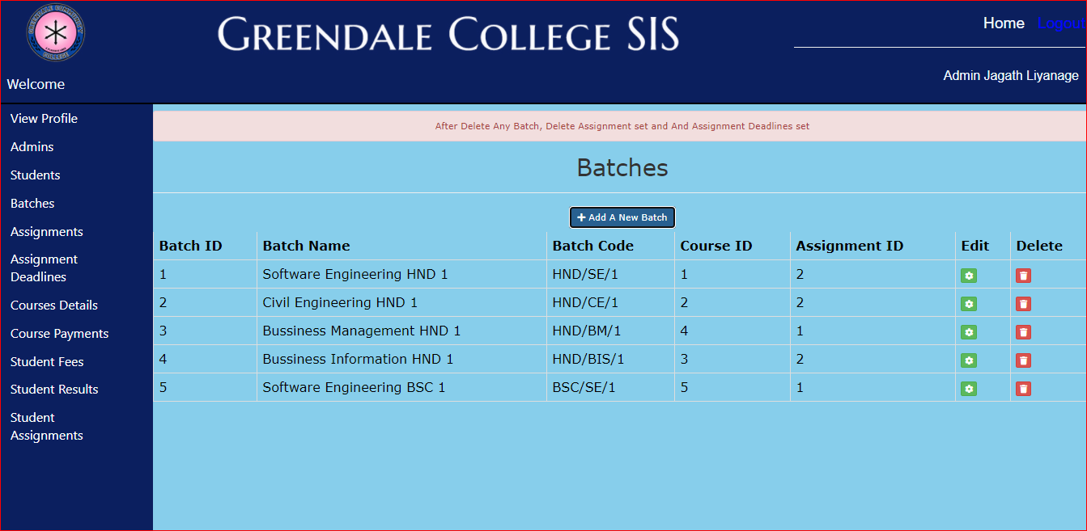

###### View Assignments

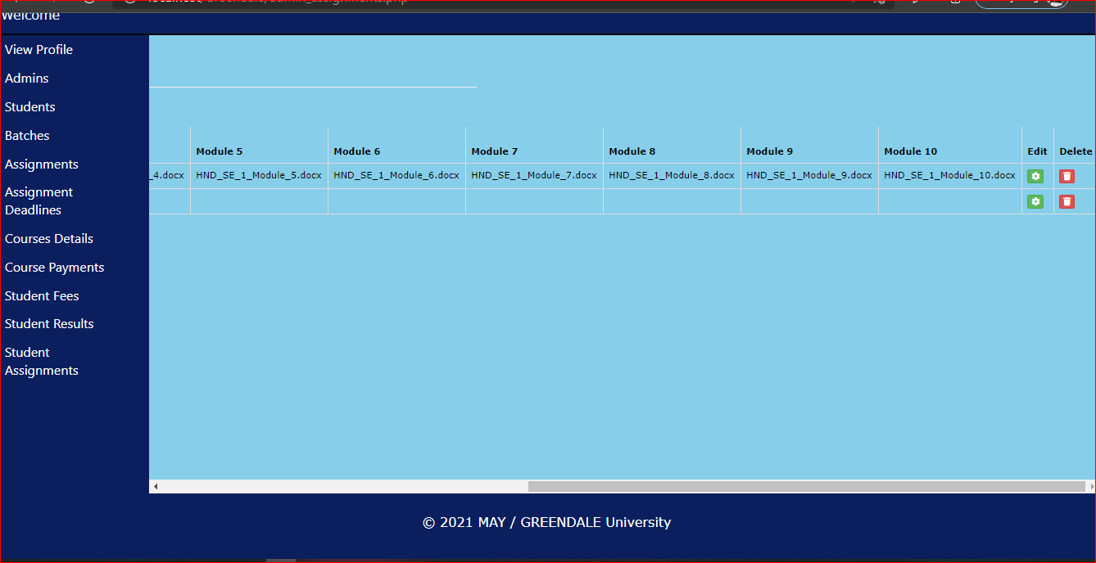

###### Assignment dead lines

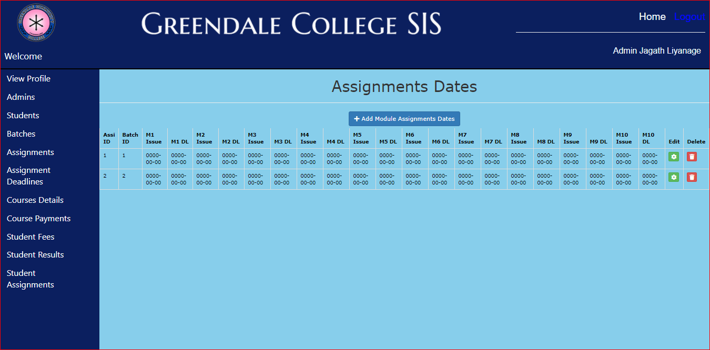

###### View course details

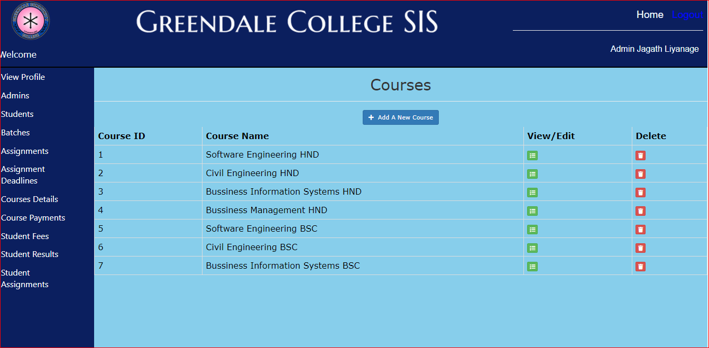

###### View s payment

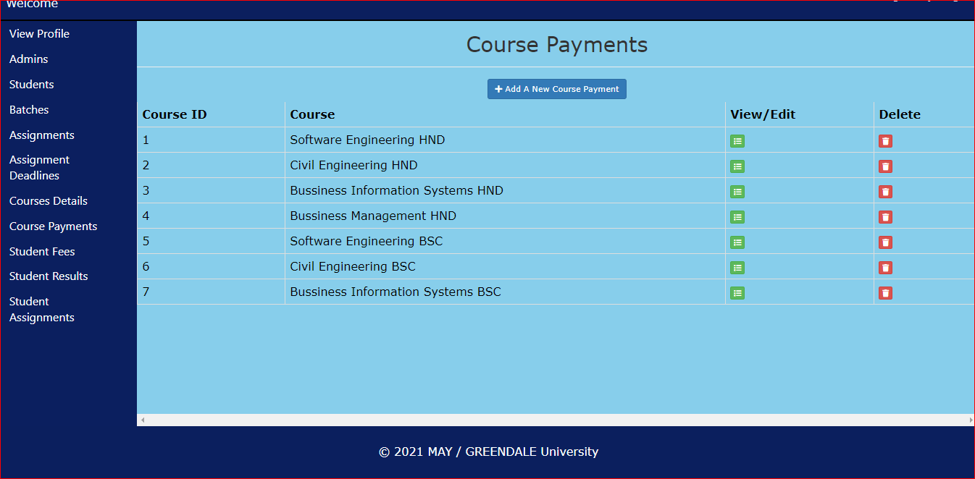

###### View students fees

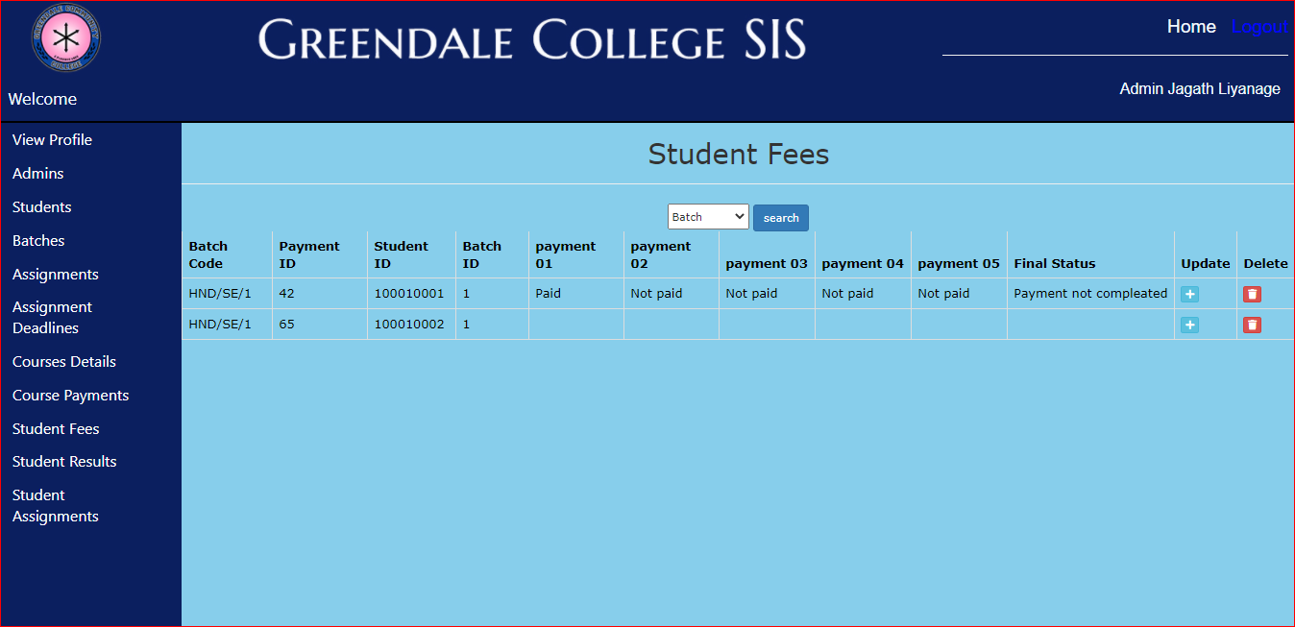

###### Student Results

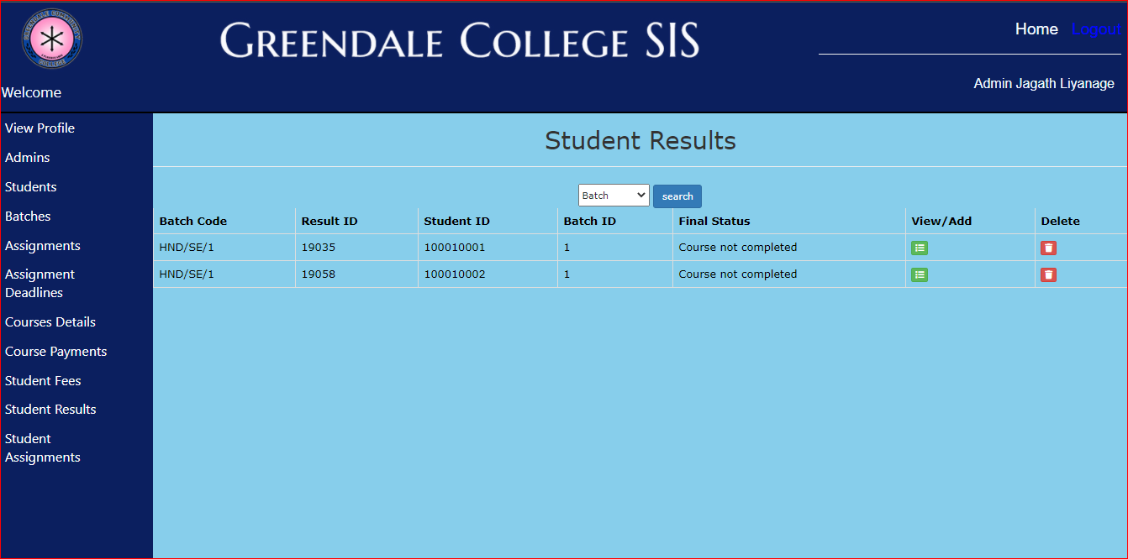

###### Students Assignments

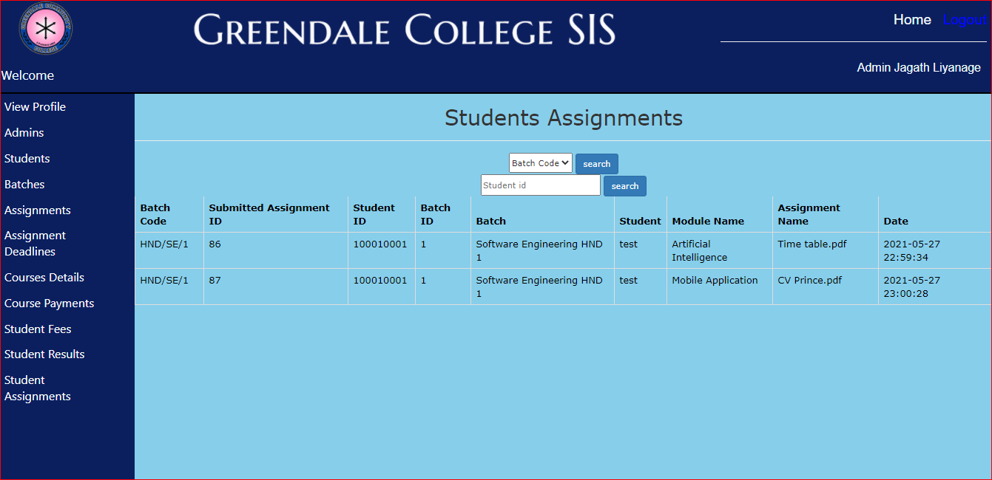

###### Students login



###### Students home page

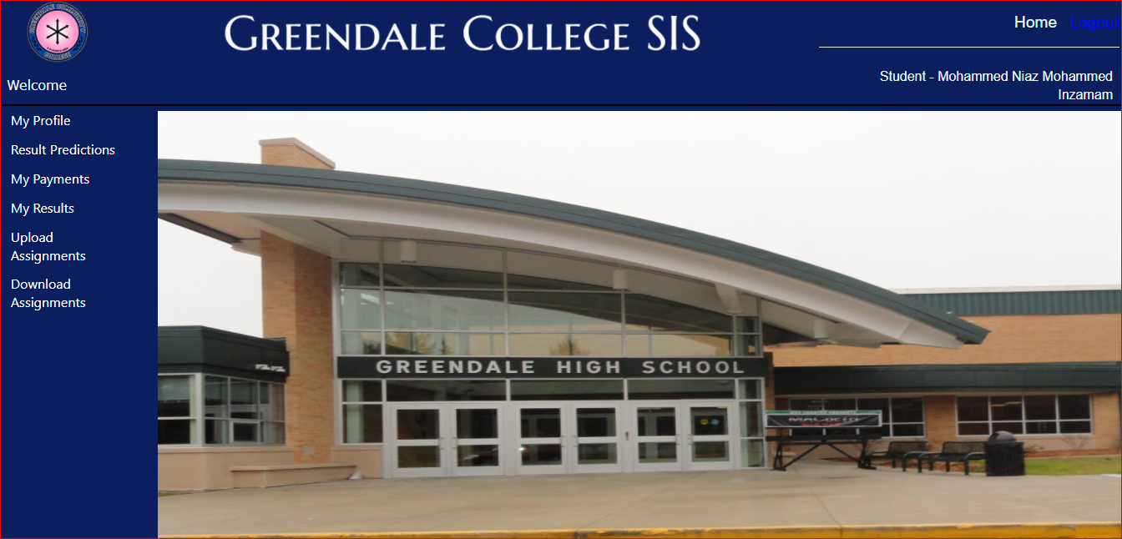

###### Student results prediction

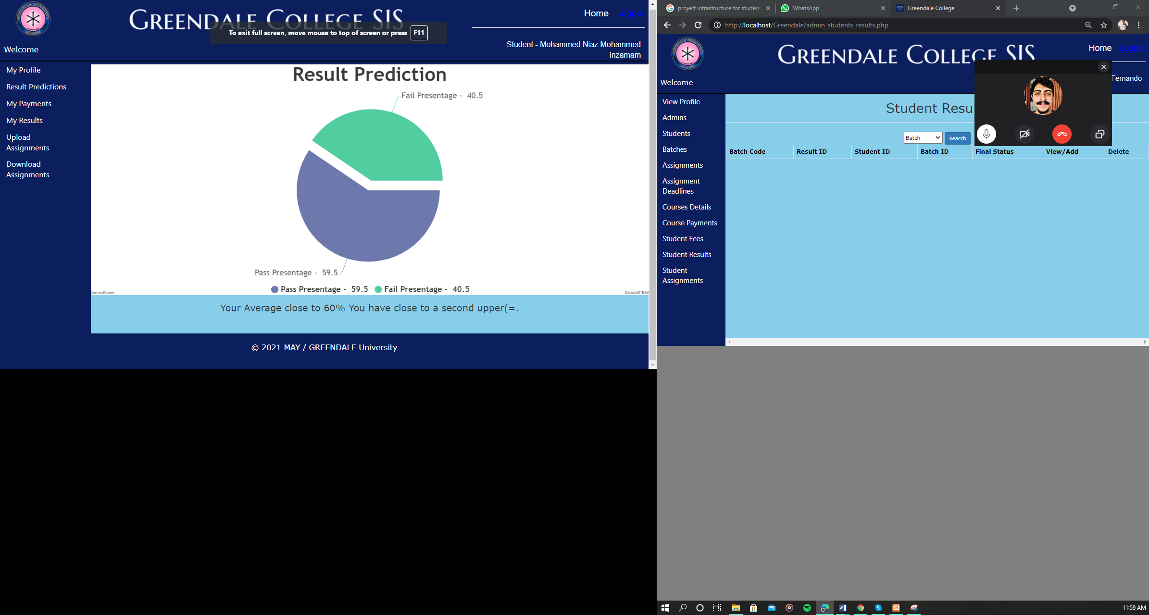

###### Student Payments

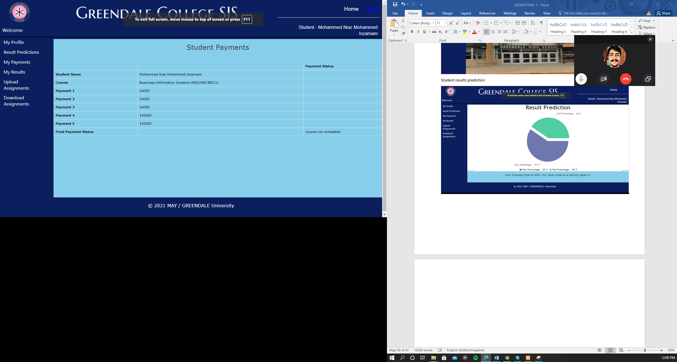

###### Student Results

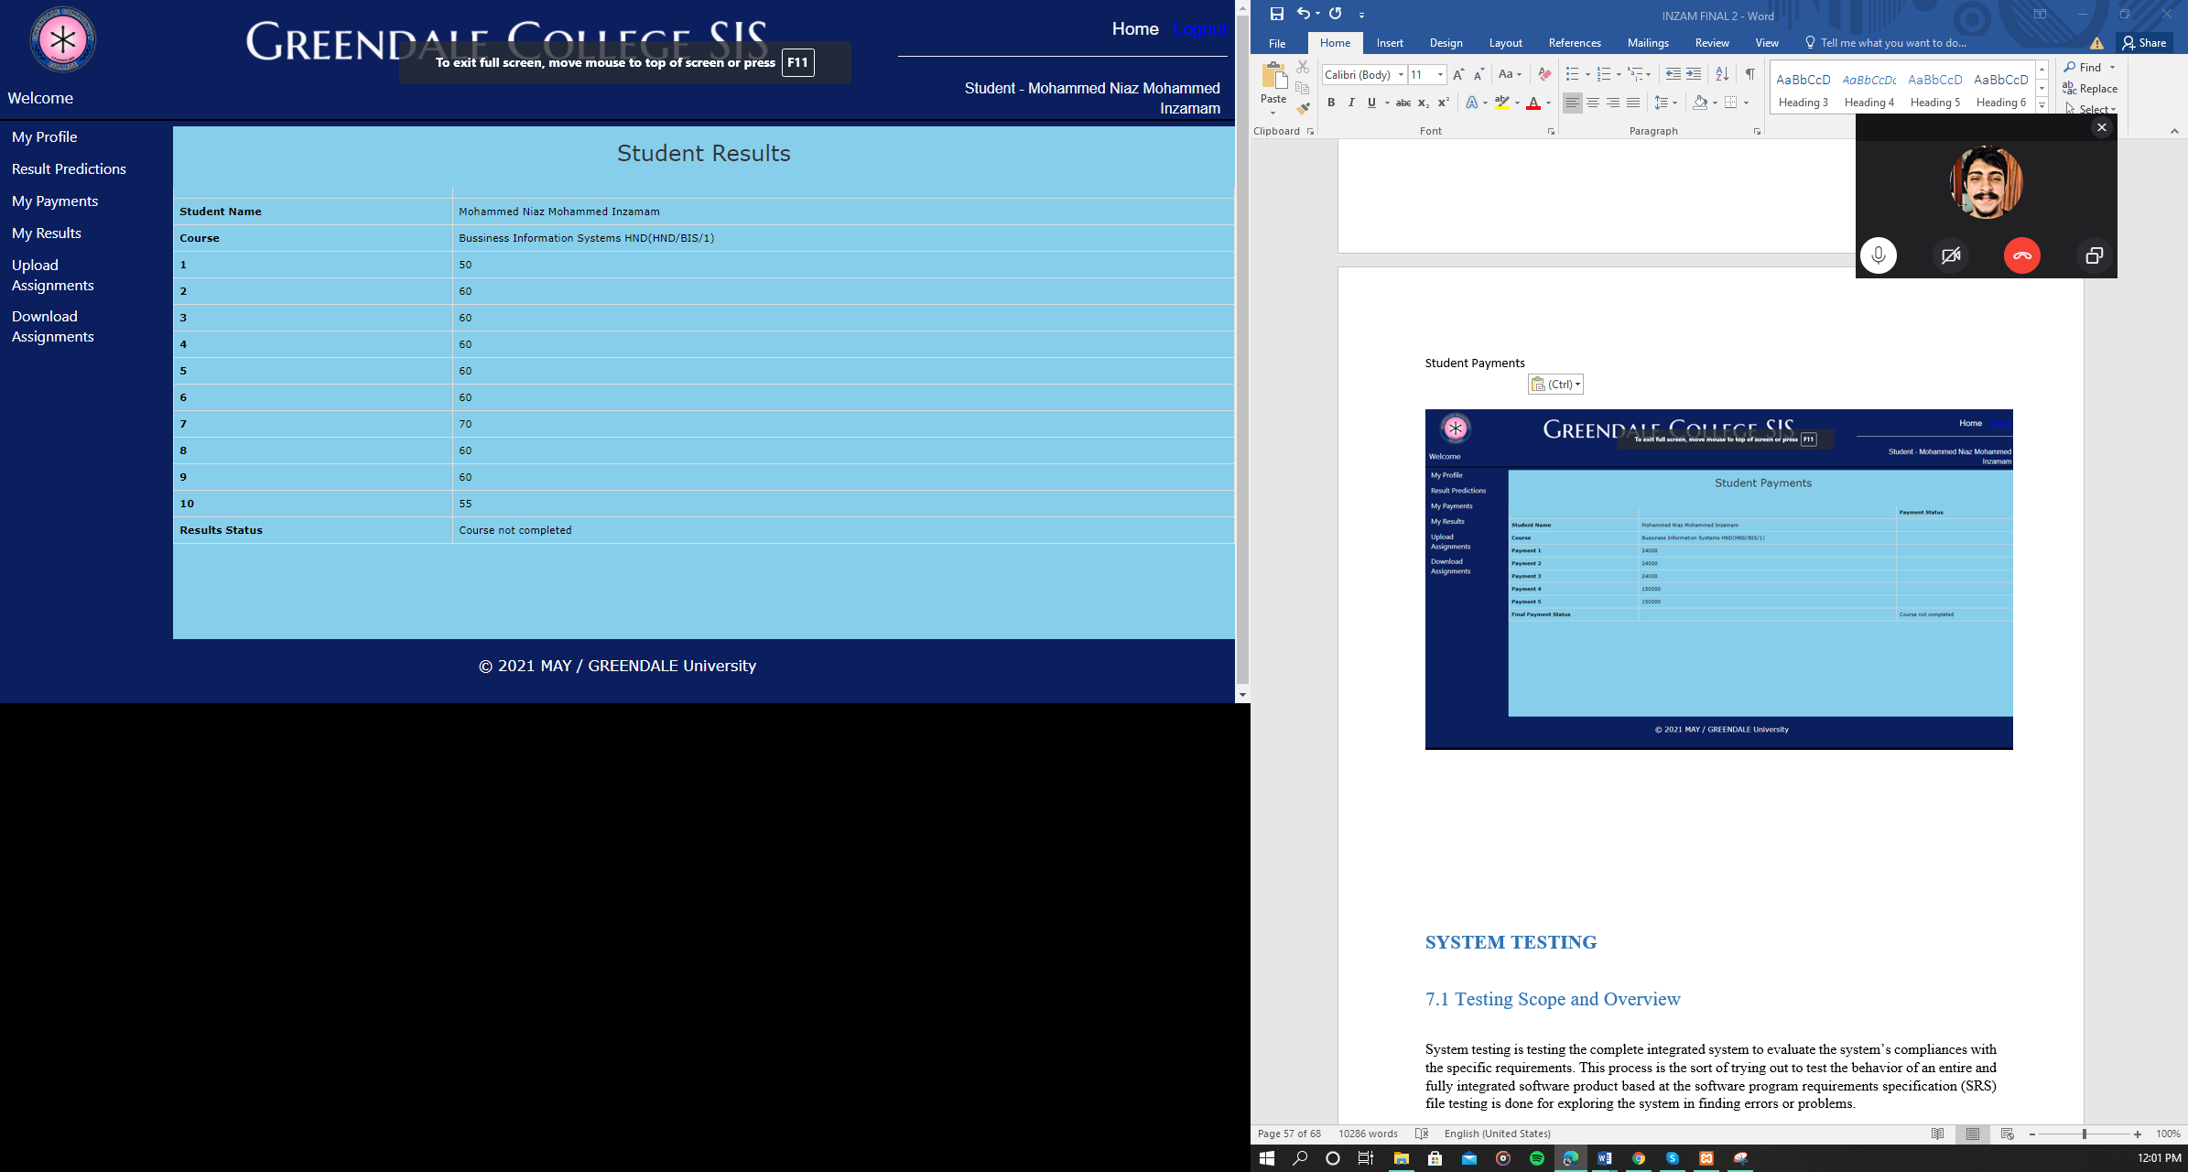

###### Upload Your Assignments

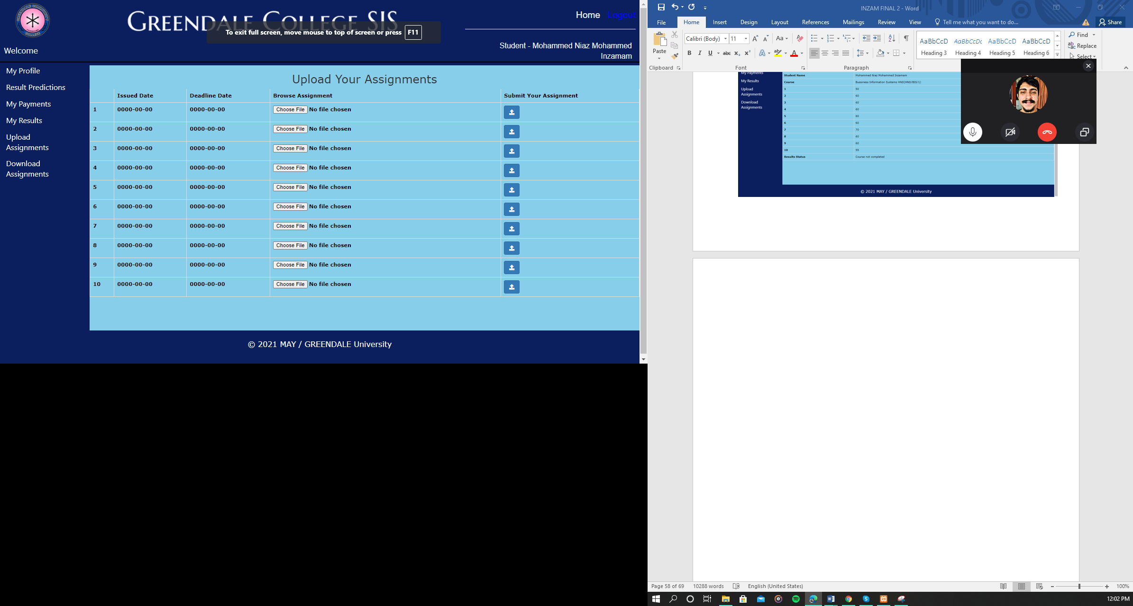

###### Module Assignments

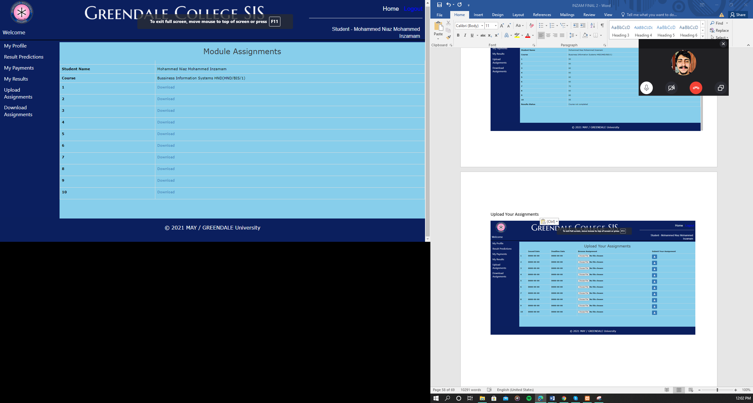

### Wireframes

###### Main index

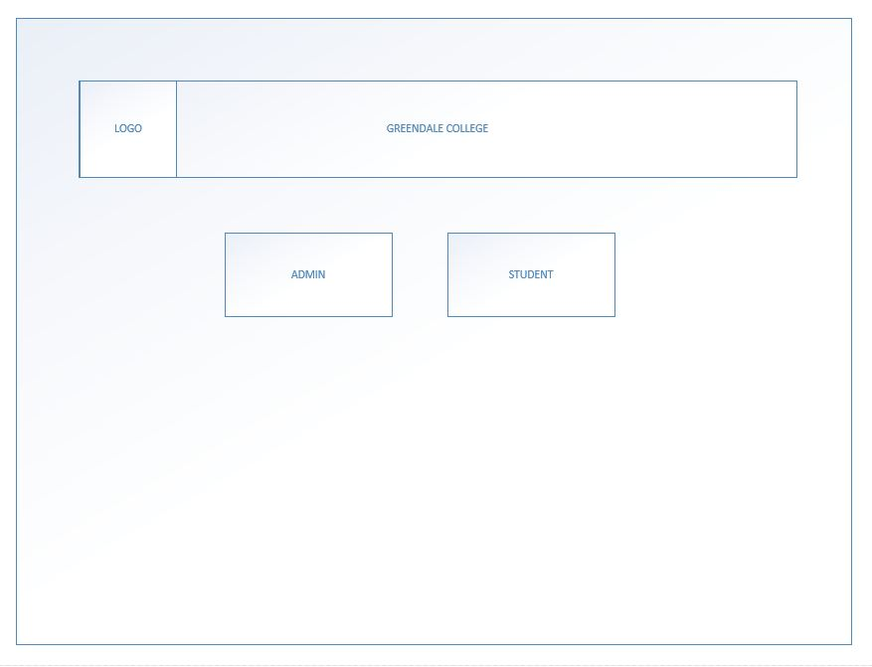

Admin login

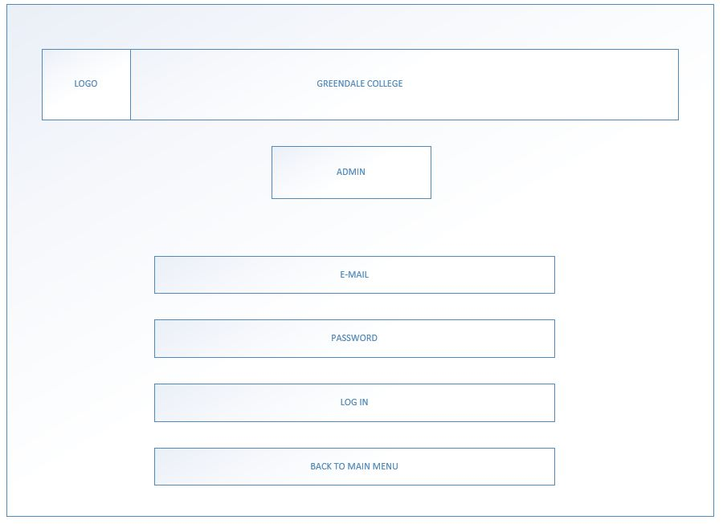

###### Admin main menu

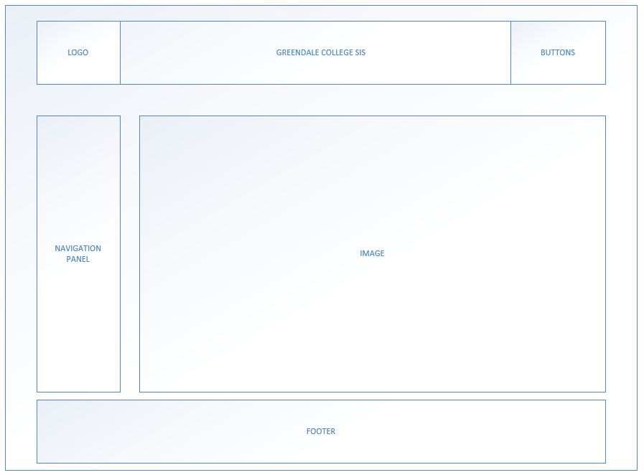

###### Admin profile

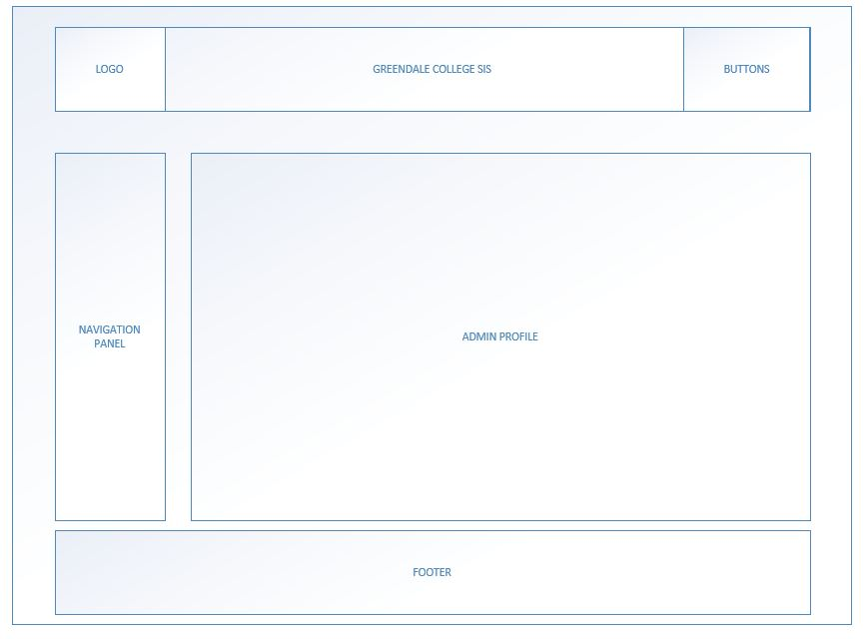

###### Admin registration

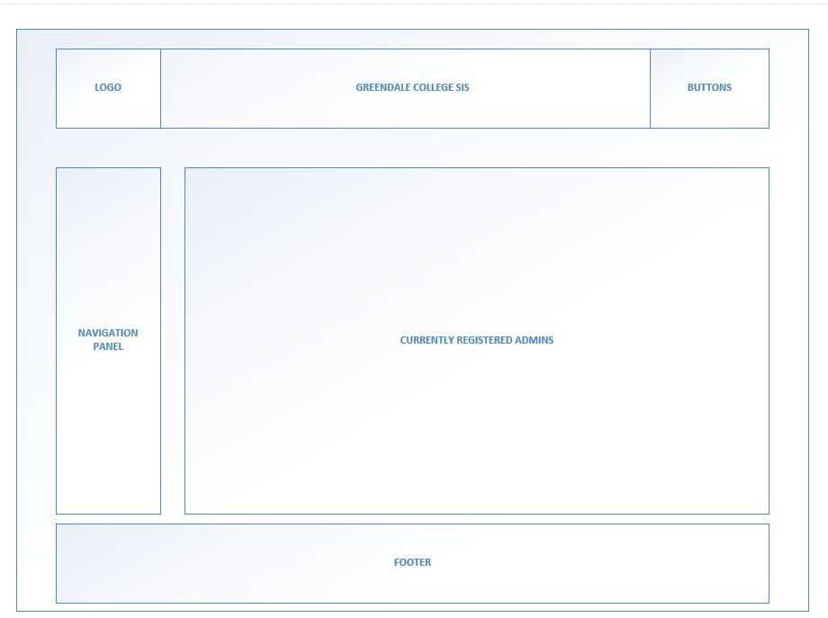

###### Admin add student

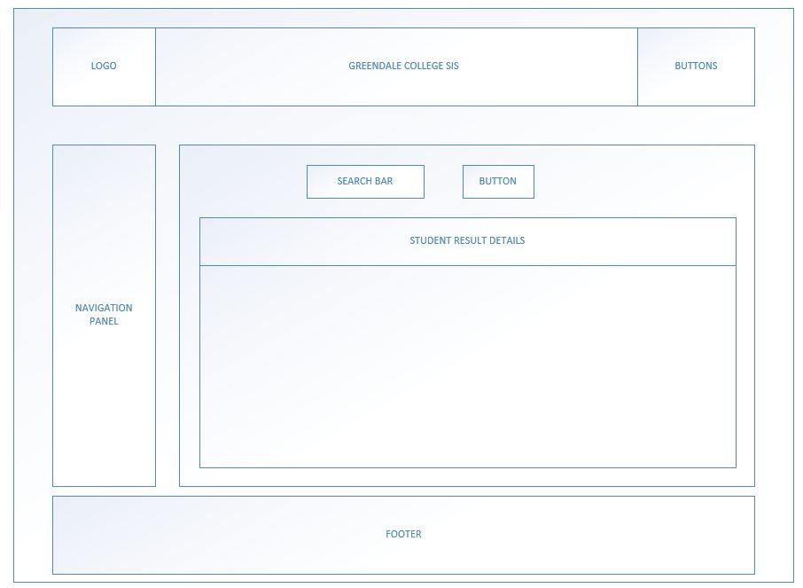

###### Admin manage Assignments

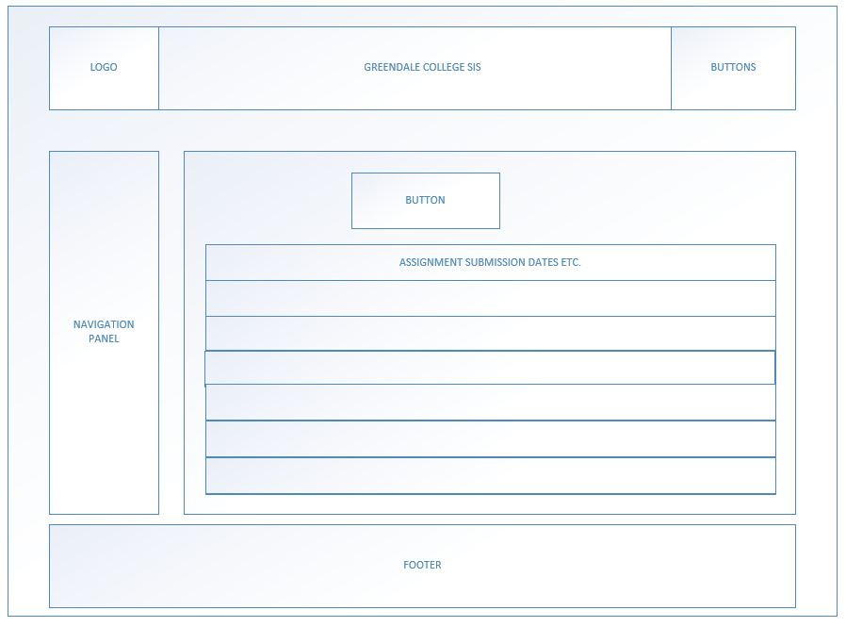

###### Admin Assignments Dates

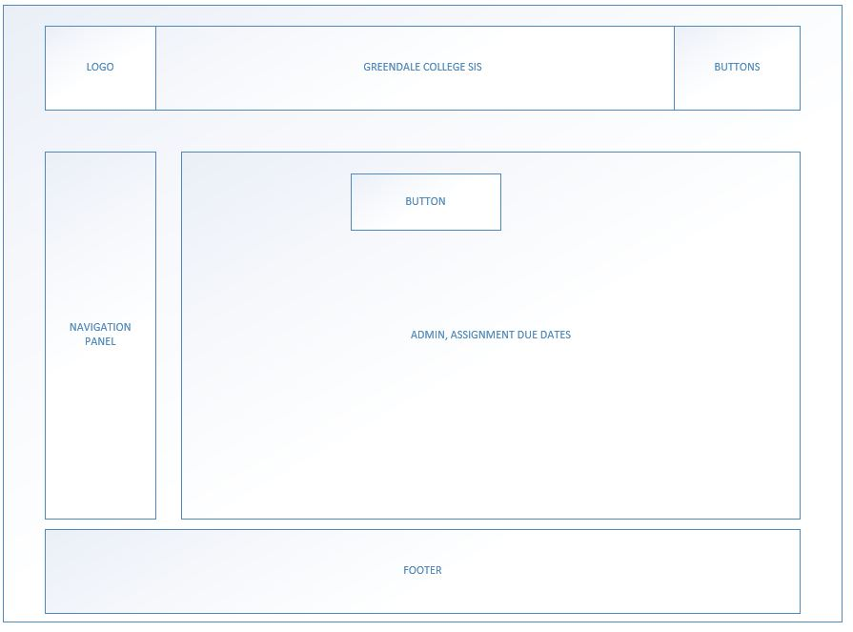

###### Admin Courses

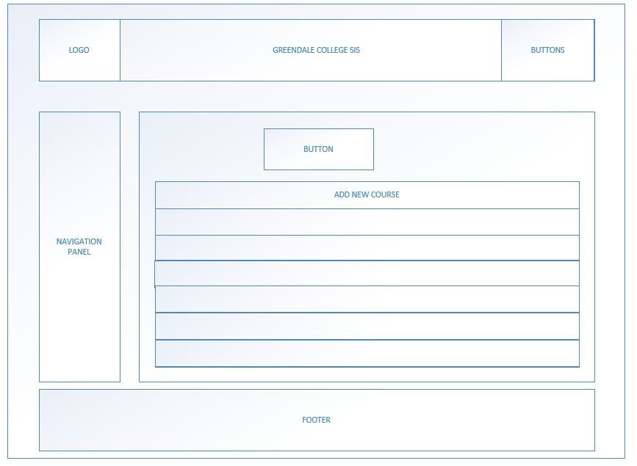

###### Admin Course Payments

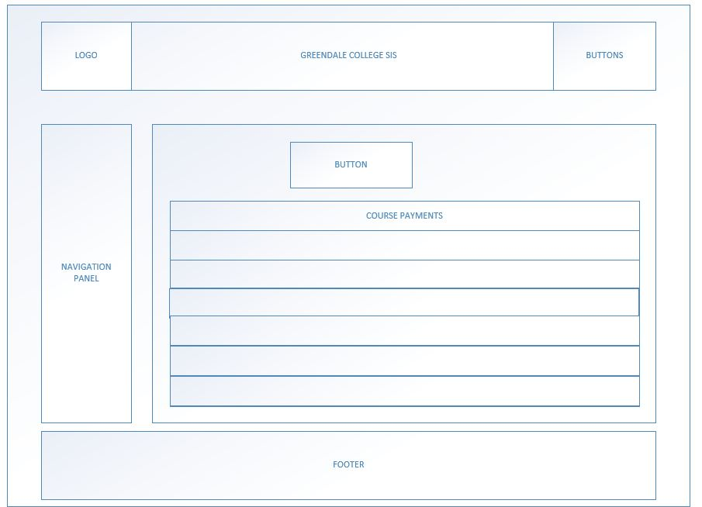

###### Admin (student course fees )

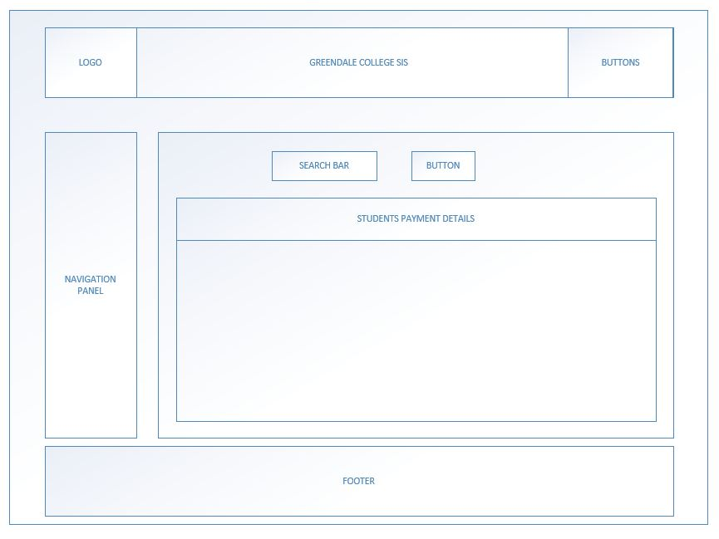

###### Admin student results



###### Admin student’s assignment

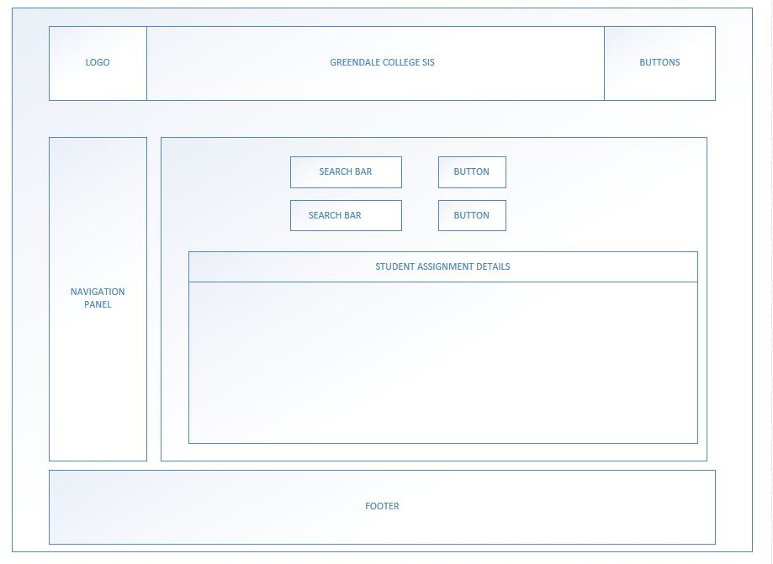

###### Student login

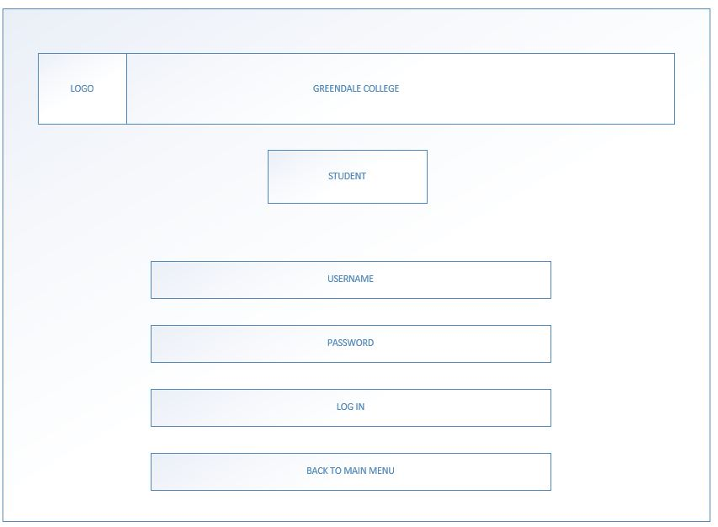

###### Student main menu

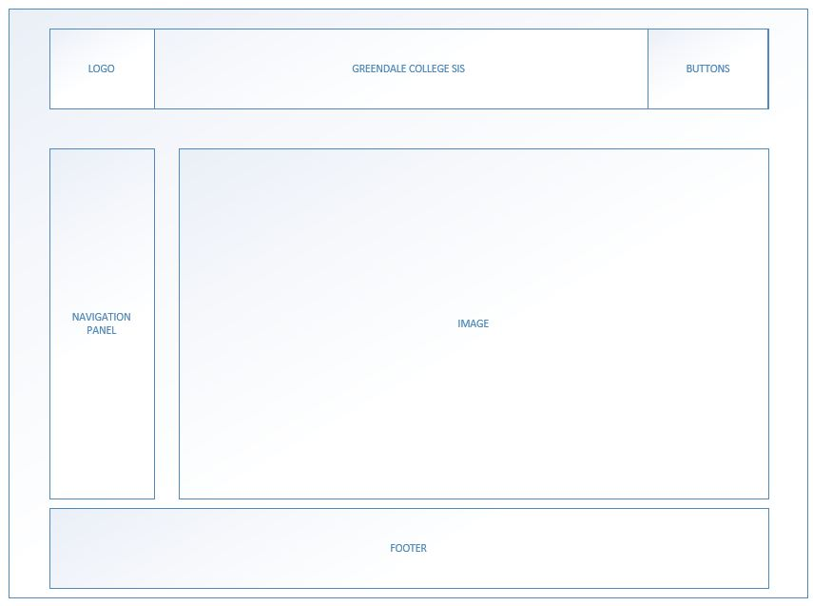

###### Students my profile

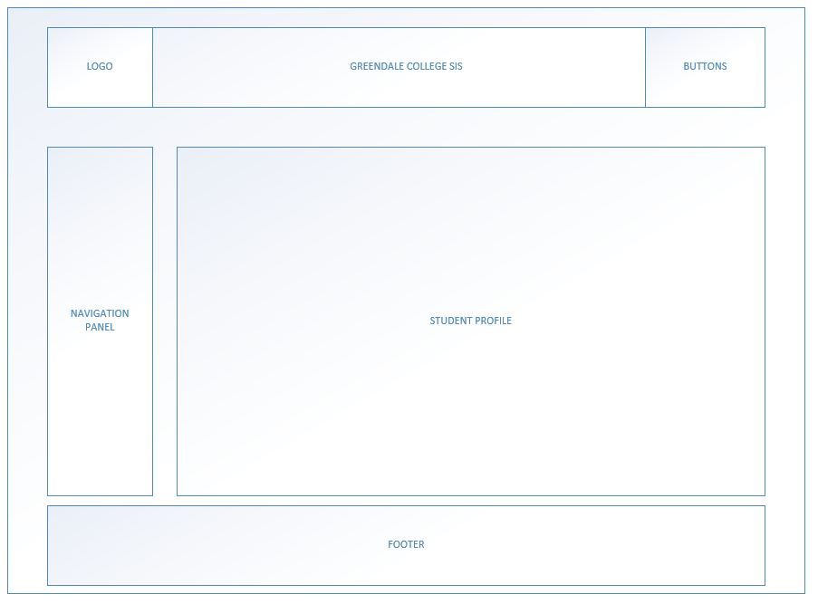

###### Student results prediction

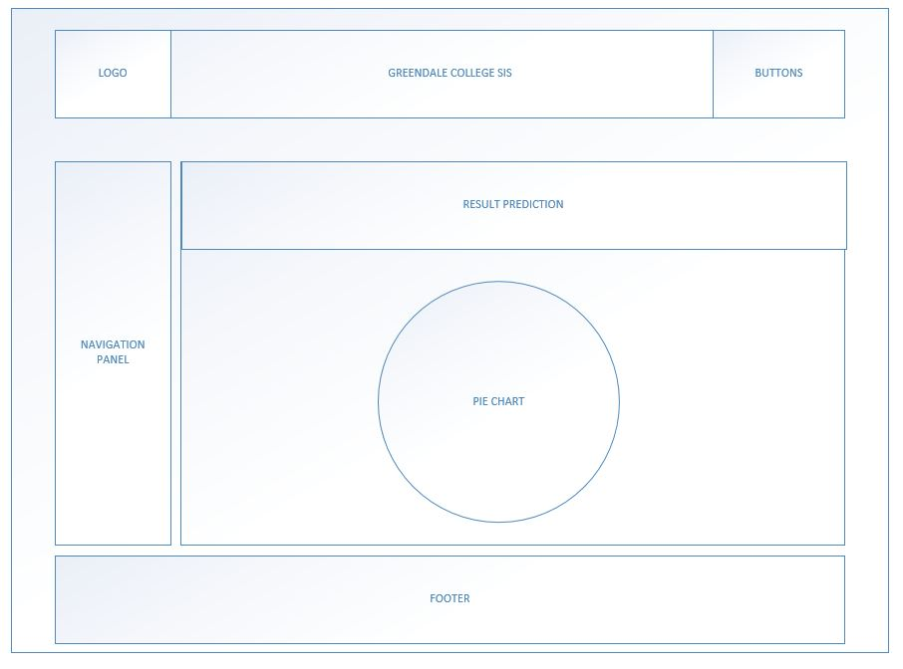

###### Students Student Payments

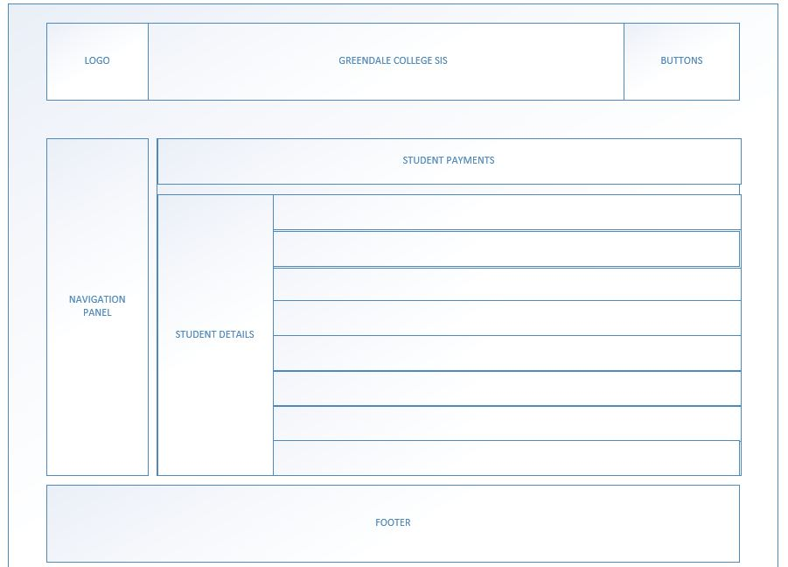

###### Students Results

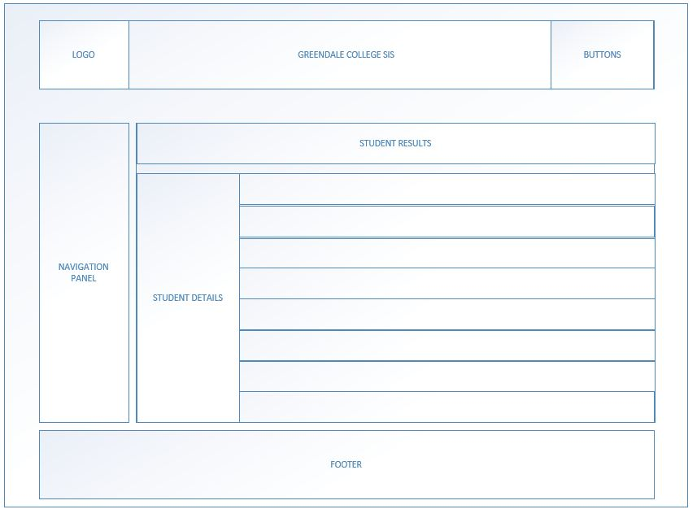

###### Upload Your Assignments

# 

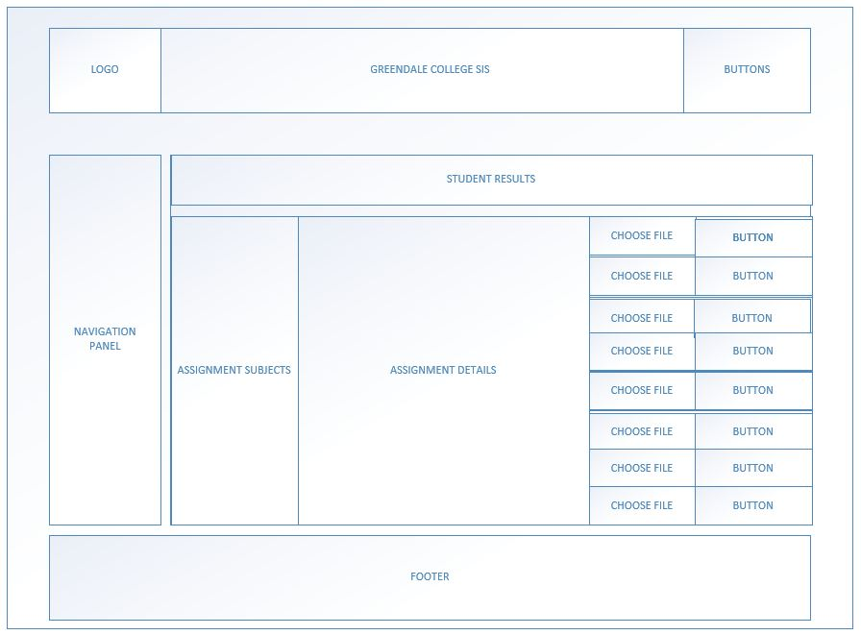

###### Students download assignments

# 



# Chapter 7

## SYSTEM TESTING

### 7.5 Testing Approach

For this system, we chose black box testing as the testing methodology. We chose black box because we just care about the software system's inputs and outputs and aren't concerned with the program's internal knowledge. The benefits of adopting black box testing include the fact that it is unbiased because the designer and tester work independently. Furthermore, the tester is not under any obligation to know certain programming languages in order to evaluate the software's reliability and functionality. And the other fact that we select black box testing as our testing methodology is because that the test is performed from a user’s point of view and not of the designer’s. Also, test cases can be created just once the specification is finished. Although black box testing does not thoroughly test a system, it can nevertheless assist in meeting a user's expectations from an application or software.

## 7.2 Test Plan & Cases

### Users Test Plan

|  |  |  |  |
| --- | --- | --- | --- |
| Test Case ID | Test Case Name | Scenario | Results |
| TC1 | Login (admin) | Click the "login" button without filling the fields | Displays an error message |
| TC2 | Login (admin) | Incorrectly inputting a User ID or password To login in, click the "login" tab. | Displays an error message |
| TC3 | Login (admin) | Correcting the User ID and Password To log in, select the “login” button. | Directly going to the admin home page |
| TC4 | Profile (admin) | On the navigation bar, choose the "Profile" button. | Directly going to the admin page |
| TC5 | Page (admins) | On the MENU bar, select the “admins” tab. | Directly going to the admins Page |
| TC6 | Adding (new) Administrator | Press the add new admin button | Add new Administrator has been opened |
| TC7 | Adding (new) Administrator | Without filling the fields, press on insert button | Displays an error message |
| TC8 | Adding (new) Administrator | Correctly fill the fields and select the insert button | Displays information in the table |
| TC9 | Update Administrator function | Press the update button | Update Admins model. Has been opened |
| TC10 | Update Administrator function | to update the current details, select the update option | Updates the information in the table. |
| TC11 | Delete function for Administrator | Press the delete button to remove the data | Delete the information from the table. |
| TC12 | Administrator (view student function) | Click on the “students” button on the menu bar | Directly going to Administrator students page |
| TC13 | Administrator (view student details function) | Choose a batch code first from drop-down menu and press the "Search" option. | View information about the batch of students. |
| TC14 | Administrator (add new students) | Select "add new students" from the drop-down menu. | Select “Add new students” from the  menu. |
| TC15 | Administrator (add new students) | Select the "Insert" button without adding any details. | Displays an error message |
| TC16 | Administrator (add new students) | Press the "Insert" option after filling in the information | In the table, display new data. |
| TC17 | Administrator student update function | On the page, select the "update" option. | “Update students” should now be open. |
| TC18 | Administrator student update function | Details have been updated. Select "Update" from the drop-down menu. | In the table, it shows updated data. |
| TC19 | Administrator student delete function | Select "Delete" from the drop-down menu. | Delete the information from the table. |
| TC20 | Administrator Batches function | On the navigation bar, select the “ Batches” option. | Directly going to the Batches function |
| TC21 | Ad Administrator min add new batches function | To establish a new batch, select the "add new Batch" option. | “Add a new Batch” should now be open. |
| TC22 | Administrator add new batches function | Press the "Insert" option without adding any information. | Displays an error message |
| TC23 | Administrator add new batches function | Select the "Insert" option after you've finished filling in the information. | Updates the table with updated information. |
| TC24 | Administrator update Batches function | On the page, select the "update" option. | “Update Batches” should now be open. |
| TC25 | Administrator update Batches function | Details have been updated. On the page, select the "Update" option. | In the table, show the most recent data. |
| TC26 | Administrator delete student batches function | On the page, select the “Delete” option. | Delete the information from the table. |
| TC27 | Administrator student Assignments Page function | On the menu bar, select the “Assignments” option. | Going straight to "Assignments" |
| TC28 | Administrator student Assignments Page function | Select "Add Module Assignments" from the drop-down menu. | “Add Module Assignments” should now be open. |
| TC29 | Administrator student Assignments Page function | Press the "Insert" button without adding any details. | Displays an error message |
| TC30 | Administrator student Assignments Page function | Select the "Insert" option after you've finished filling in the details. | In the table, show updated data. |
| TC31 | Administrator student Assignments Page function | Select "update" from the drop-down menu. | The option to "Update Module Assignments" should now. |
| TC32 | Administrator students update Assignments | Details have been updated. Select "Update" from the drop-down menu. | In the table, show the most update  data. |
| TC33 | Administrator students delete Assignments function | On the page, select the “Delete” option. | Delete the information from the table. |
| TC34 | Administrator deadline function | Go to the menu bar and select "Deadlines." | Going straight to the "Deadlines" page |
| TC35 | Administrator (deadline function and add assignments dates) | Select "Add Module Assignments Dates" from the drop-down menu. | “Add Module Assignments Dates” should now be open. |
| TC36 | Administrator (deadline function and add assignments dates) | Press the "Insert" button without adding any details. | Display Validations |
| TC37 | Administrator (deadline function and add assignments dates) | Select the "Insert" button after you've finished filling in the details. | In the table, show updated data. |
| TC38 | Administrator ( deadline and manage update assignment function) | On the page, select the "update" option. | “Update Module Assignments Dates” should now be open. |
| TC39 | Administrator ( deadline and manage update assignment function) | Details have been updated. Select "Update" from the drop-down menu. | In the table, show the most recent data. |
| TC40 | Administrator (assignment dates deletion) | Select "Delete" from the drop-down menu. | Delete the information from the table. |
| TC41 | Administrator (details of course) | On the navigation bar, select the “Course Details” option. | Directly going to Course Details |
| TC42 | Administrator (details of course and add new course) | On the page, select the “Add A New Course” option. | Open the function called “Add A New Course” |
| TC43 | Administrator (details of course and add new course) | Press the "Insert" button without adding any details. | Display Empty Validations |
| TC44 | Administrator (details of course and add new course) | Select the "Insert" button after you've finished filling in the details. | In the table, show updated data. |
| TC45 | Administrator (student update course details) | On the page, select the "update" option. | “Update AN EXISTING COURSE” should now be open. |
| TC46 | Administrator (student update course details) | Details have been updated. Select "Update" from the drop-down menu. | In the table, show the updated data. |
| TC47 | Administrator (student delete course function) | On the page, select the “Delete” option. | Delete the information from the table. |
| TC48 | Administrator student payments view page | On the menu bar, select "Manage Course Payments." | Directly going to Course Payments |
| TC50 | Administrator (new student payments view function) | On the menu bar, select "Manage Course Payments." | Add A New Course Payments has been Open |
| TC51 | Administrator (add new student course payment function) | Press the "Insert" button without adding any details. | Show Field Validations |
| TC52 | Administrator (add new student course payment function) | Select the "Insert" option after you've finished filling in the details. | In the table, show updated data. |
| TC53 | Administrator (update existing payment course) | On the page, select the "update" option. | Update AN Existing Course Payments has been open |
| TC54 | Administrator (update existing payment course) | Details have been updated. Select "Update" from the drop-down menu. | In the table, show the most recent data. |
| TC55 | Administrator (delete student course payment) | Select "Delete" from the drop-down menu. | Show the most current data in the table. |
| TC56 | Administrator (student fees function) | On the menu bar, select the “Fees” option. | student Fees page has been loaded |
| TC57 | Administrator (view student fees function) | Choose a batch code from the drop-down menu and press the "Search" option. | View the batch Fees |
| TC58 | Administrator (manage student fees function) | Select "Add" from the drop-down menu. | “Student Fee Details” has been opened |
| TC59 | Administrator (manage student fees function) | Select the "Update" button after inputting the fee status. | Display updated data in the table |
| TC60 | Administrator (fees delete details page for student) | On the page, select the “Delete” option. | In the table, show the most data. |
| TC61 | Admins (students Results function) | On the menu bar, click the “Manage Results” option. | Directly going to the Admins Results |
| TC62 | Administrator (view students Results function) | Press the "Search" button after selecting the batch code from the drop-down menu. | View the selected batch Fees |
| TC63 | Administrator (student results function) | Select "Add" from the drop-down menu. | Student Results Details” has been Opened |
| TC64 | Administrator (student manage results function) | Select the "Update" button after inputting the fee status. | In the table, show the updated data. |
| TC65 | Administrator (student delete results) | On the page, select the “Delete” option. | Delete the information from the table. |

|  |  |  |  |
| --- | --- | --- | --- |
| TC66 | Administrator (student assignment submitted details function) | On the menu bar, select the “Submitted Assignment” option. | Directly going to Submitted Assignment |
| TC67 | Administrator (student assignment submitted details view function) | Choose a batch code from the drop-down menu and press the "Search" button. | View the assignments that were submitted in the selected batch. |
| TC68 | Administrator (student assignment submitted details view function) | Select the “Search” button on the page to find the student. | Exams that have been submitted can be seen by student ID. |
| TC69 | Administrator (Log Out function) | On the header, select the "Log out option." | Successfully Logged out the session |
| TC170 | Registered Students Login function | Without filling the fields click the “login” option. | Displays an error message |
| TC71 | Registered Students Login function | Filed the filed Incorrectly, click the “login” option. | Displays an error message |
| TC72 | Registered Students Login function | Correcting the User Name or Password To log in, click the “login” button. | Directly going to Students Home Page |
| TC73 | Registered Students view profile function | On the menu bar, click the “My Profile” option. | Directly to Students My Profile” |
| TC74 | Registered Students view profile function | On the page, click the “Password visibility” option. | Password went invisible |
| TC75 | Registered Students Results Prediction function | On the menu bar, select the “Results Prediction page” option. | Directly going to the Students Results Prediction page Show on the students’ progress. |
| TC76 | Registered Student Payments view page | On the menu bar, select the “View Payments” option. | Directly going to Students View Payment |
| TC78 | Registered Students View assignment and exam Results page | On the menu bar, select the “View Results” option. | Directly going to Students View Results |
| TC79 | Registered Students assignments submission page | On the menu bar, select the “Submit assignment” option. | Directly going to Students Submit assignee |
| TC80 | Registered Students assignments submission page and select assignment | On Selected Assignment, select the “Choose File” option. | Activate the File Browser |
| TC81 | Registered Students assignments submission page | Click on the “Submit” button on Selected Assignment | *Message showed ‘Successfully submitted’* |
| TC82 | Registered Students assignments submission page | On the Selected Assignment page, select the "Submit" option. | *“Your Extension must be PDF,” said the error message.* |
| TC83 | Registered Students Download assignments function | On the menu bar, select the “Download assignments” option. | Directly going to Students Download assignments |
| TC84 | Registered Students Download assignments function and select assignment | On Selected Assignment, select the “Choose File” option. | Activate the File Browser |
| TC85 | Registered Students Download assignment function. | On the Selected Assignment page, select the "Download" option. | Selecting an Assignment to Download |

## Test cases

|  |  |
| --- | --- |
| Test case | Test Cases 1 |
| Test objective | Login (admin) |
| Test Data | Click the "login" button without filling the fields |
| Expected Result | Displays an error message |
| Conclusion | Displays an error message |
| Screen shots |  |

|  |  |
| --- | --- |
| Test case 2 | Test Cases 2 |
| Test objective | Login (admin) |
| Test Data | Incorrectly inputting a User ID or password To login in, click the "login" tab. |
| Expected Result | Displays an error message |
| Conclusion | Displays an error message |
| Screen shots |  |

|  |  |
| --- | --- |
| Test case 3 | Test Cases 3 |
| Test objective | Login (admin) |
| Test Data | Correcting the User ID and Password To log in, select the “login” button. |
| Expected Result | Directly going to the admin page |
| Conclusion | Directly going to the admin page |
| Screen shots |  |

|  |  |
| --- | --- |
| Test case 4 | Test Cases 4 |
| Test objective | Profile (admin) |
| Test Data | On the navigation bar, choose the "Profile" button. |
| Expected Result | Directly going to the admin page |
| Conclusion | Directly going to the admin page |
| Screen shots |  |

|  |  |
| --- | --- |
| Test case 5 | Test Cases 5 |
| Test objective | Page (admins) |
| Test Data | On the MENU bar, select the “admins” tab. |
| Expected Result | Directly going to the admins Page |
| Conclusion | Directly going to the admins Page |
| Screen shots |  |

|  |  |
| --- | --- |
| Test case 6 | Test Cases 6 |
| Test objective | Adding (new) Administrator |
| Test Data | Press the add new admin button |
| Expected Result | Add new Administrator has been opened |
| Conclusion | Add new Administrator has been opened |
| Screen shots |  |

|  |  |
| --- | --- |
| Test case 2 | Test Cases 7 |
| Test objective | Adding (new) Administrator |
| Test Data | Correctly fill the fields and select the insert button |
| Expected Result | Displays an error message |
| Conclusion | Displays an error message |
| Screen shots |  |

|  |  |
| --- | --- |
| Test case 8 | Test Cases 8 |
| Test objective | Adding (new) Administrator |
| Test Data | Correctly fill the fields and select the insert button |
| Expected Result | Correctly fill the fields and select the insert button |
| Conclusion | Displays new data in the table |
| Screen shots |  |

|  |  |
| --- | --- |
| Test case 2 | Test Cases 9 |
| Test objective | Update Administrator function |
| Test Data | Click on the “update” button on the page |
| Expected Result | Update Admins model. Has been opened |
| Conclusion | Update Admins model. Has been opened |
| Screen shots |  |

|  |  |
| --- | --- |
| Test case 2 | Test Cases 10 |
| Test objective | Update Administrator function |
| Test Data | to update the current details, select the update option |
| Expected Result | Updates the information in the table. |
| Conclusion | Updates the information in the table. |
| Screen shots |  |

|  |  |
| --- | --- |
| Test case 11 | Test Cases 11 |
| Test objective | Delete function for Administrator |
| Test Data | Press the delete button to remove the data |
| Expected Result | Delete the information from the table. |
| Conclusion | Delete the information from the table. |
| Screen shots |  |

|  |  |
| --- | --- |
| Test case 12 | Test Cases 12 |
| Test objective | Administrator (view student function) |
| Test Data | Click on the “students” button on the menu bar |
| Expected Result | View information about the batch of students. |
| Conclusion | View information about the batch of students. |
| Screen shots |  |

|  |  |
| --- | --- |
| Test case 13 | Test Cases 13 |
| Test objective | Administrator (view student details function) |
| Test Data | Choose a batch code first from drop-down menu and press the "Search" option. |
| Expected Result | View information about the batch of students. |
| Conclusion | View information about the batch of students. |
| Screen shots |  |

|  |  |
| --- | --- |
| Test case 2 | Test Cases 14 |
| Test objective | Administrator (add new students) |
| Test Data | Select "add new students" from the drop-down menu. |
| Expected Result | Select “Add new students” from the  menu. |
| Conclusion | Select “Add new students” from the  menu. |
| Screen shots |  |

|  |  |
| --- | --- |
| Test case 15 | Test Cases 15 |
| Test objective | Administrator (add new students) |
| Test Data | Select the "Insert" button without adding any details. |
| Expected Result | Displays an error message |
| Conclusion | Displays an error message |
| Screen shots |  |

|  |  |
| --- | --- |
| Test case 2 | Test Cases 16 |
| Test objective | Administrator (add new students) |
| Test Data | Press the "Insert" option after filling in the information |
| Expected Result | In the table, display new data. |
| Conclusion | In the table, display new data. |
| Screen shots |  |

|  |  |
| --- | --- |
| Test case 2 | Test Cases 17 |
| Test objective | Administrator student update function |
| Test Data | On the page, select the "update" option. |
| Expected Result | “Update students” should now be open. |
| Conclusion | “Update students” should now be open. |
| Screen shots |  |

|  |  |
| --- | --- |
| Test case 2 | Test Cases 18 |
| Test objective | Administrator student update function |
| Test Data | Details have been updated. Select "Update" from the drop-down menu. |
| Expected Result | In the table, it shows updated data. |
| Conclusion | In the table, it shows updated data. |
| Screen shots |  |

|  |  |
| --- | --- |
| Test case 19 | Test Cases 19 |
| Test objective | Administrator student delete function |
| Test Data | Click on the “Delete” button |
| Expected Result | Delete the data from table |
| Conclusion | Delete the data from table |
| Screen shots |  |

|  |  |
| --- | --- |
| Test case 20 | Test Cases 20 |
| Test objective | Administrator Batches function |
| Test Data | On the navigation bar, select the “ Batches” option. |
| Expected Result | Directly going to the Batches function |
| Conclusion | Directly going to the Batches function |
| Screen shots |  |

|  |  |
| --- | --- |
| Test case 21 | Test Cases 21 |
| Test objective | Ad Administrator min add new batches function |
| Test Data | To establish a new batch, select the "add new Batch" option. |
| Expected Result | “Add a new Batch” should now be open. |
| Conclusion | “Add a new Batch” should now be open. |
| Screen shots |  |

|  |  |
| --- | --- |
| Test case 22 | Test Cases 22 |
| Test objective | Administrator add new batches function |
| Test Data | Press the "Insert" option without adding any information. |
| Expected Result | Displays an error message |
| Conclusion | Displays an error message |
| Screen shots |  |

|  |  |
| --- | --- |
| Test case 23 | Test Cases 23 |
| Test objective | Administrator add new batches function |
| Test Data | Select the "Insert" option after you've finished filling in the information. |
| Expected Result | Updates the table with updated information. |
| Conclusion | Updates the table with updated information. |
| Screen shots |  |

|  |  |
| --- | --- |
| Test case 2 | Test Cases 24 |
| Test objective | Administrator update Batches function |
| Test Data | On the page, select the "update" option. |
| Expected Result | “Update Batches” should now be open. |
| Conclusion | “Update Batches” should now be open. |
| Screen shots |  |

|  |  |
| --- | --- |
| Test case 25 | Test Cases 25 |
| Test objective | Administrator update Batches function |
| Test Data | Details have been updated. On the page, select the "Update" option. |
| Expected Result | In the table, show the most recent data. |
| Conclusion | In the table, show the most recent data. |
| Screen shots |  |

|  |  |
| --- | --- |
| Test case 26 | Test Cases 26 |
| Test objective | Administrator delete student batches function |
| Test Data | On the page, select the “Delete” option. |
| Expected Result | Delete the information from the table. |
| Conclusion | Delete the information from the table. |
| Screen shots |  |

|  |  |
| --- | --- |
| Test case 27 | Test Cases 27 |
| Test objective | Administrator student Assignments Page function |
| Test Data | On the menu bar, select the “Assignments” option. |
| Expected Result | Going straight to "Assignments" |
| Conclusion | Going straight to "Assignments" |
| Screen shots |  |

|  |  |
| --- | --- |
| Test case 28 | Test Cases 28 |
| Test objective | Administrator student Assignments Page function |
| Test Data | Select "Add Module Assignments" from the drop-down menu. |
| Expected Result | “Add Module Assignments” should now be open. |
| Conclusion | “Add Module Assignments” should now be open. |
| Screen shots |  |

|  |  |
| --- | --- |
| Test case 29 | Test Cases 29 |
| Test objective | Administrator student Assignments Page function |
| Test Data | Press the "Insert" button without adding any details. |
| Expected Result | Displays an error message |
| Conclusion | Displays an error message |
| Screen shots |  |

|  |  |
| --- | --- |
| Test case 30 | Test Cases 30 |
| Test objective | Administrator student Assignments Page function |
| Test Data | Select the "Insert" option after you've finished filling in the details. |
| Expected Result | In the table, show updated data. |
| Conclusion | In the table, show updated data. |
| Screen shots |  |

|  |  |
| --- | --- |
| Test case 31 | Test Cases 31 |
| Test objective | Administrator student Assignments Page function |
| Test Data | Select "update" from the drop-down menu. |
| Expected Result | The option to "Update Module Assignments" should now. |
| Conclusion | The option to "Update Module Assignments" should now. |
| Screen shots |  |

|  |  |
| --- | --- |
| Test case 32 | Test Cases 32 |
| Test objective | Administrator students update Assignments |
| Test Data | Details have been updated. Select "Update" from the drop-down menu. |
| Expected Result | In the table, show the most update  data. |
| Conclusion | In the table, show the most update  data. |
| Screen shots |  |

|  |  |
| --- | --- |
| Test case 33 | Test Cases 33 |
| Test objective | Administrator students delete Assignments function |
| Test Data | On the page, select the “Delete” option. |
| Expected Result | Delete the information from the table. |
| Conclusion | Delete the information from the table. |
| Screen shots |  |

|  |  |
| --- | --- |
| Test case 34 | Test Cases 34 |
| Test objective | Administrator deadline function |
| Test Data | Go to the menu bar and select "Deadlines." |
| Expected Result | Going straight to the "Deadlines" page |
| Conclusion | Going straight to the "Deadlines" page |
| Screen shots |  |

|  |  |
| --- | --- |
| Test case 35 | Test Cases 35 |
| Test objective | Administrator (deadline function and add assignments dates) |
| Test Data | Select "Add Module Assignments Dates" from the drop-down menu. |
| Expected Result | “Add Module Assignments Dates” should now be open. |
| Conclusion | “Add Module Assignments Dates” should now be open. |
| Screen shots |  |

|  |  |
| --- | --- |
| Test case 36 | Test Cases 36 |
| Test objective | Administrator (deadline function and add assignments dates) |
| Test Data | Press the "Insert" button without adding any details |
| Expected Result | Display Validations |
| Conclusion | Display Validations |
| Screen shots |  |

|  |  |
| --- | --- |
| Test case 37 | Test Cases 37 |
| Test objective | Administrator (deadline function and add assignments dates) |
| Test Data | Select the "Insert" button after you've finished filling in the details. |
| Expected Result | In the table, show updated data. |
| Conclusion | In the table, show updated data. |
| Screen shots |  |

|  |  |
| --- | --- |
| Test case 38 | Test Cases 38 |
| Test objective | Administrator ( deadline and manage update assignment function) |
| Test Data | On the page, select the "update" option. |
| Expected Result | “Update Module Assignments Dates” should now be open. |
| Conclusion | “Update Module Assignments Dates” should now be open. |
| Screen shots |  |

|  |  |
| --- | --- |
| Test case 39 | Test Cases 39 |
| Test objective | Administrator ( deadline and manage update assignment function) |
| Test Data | Details have been updated. Select "Update" from the drop-down menu. |
| Expected Result | In the table, show the most recent data. |
| Conclusion | In the table, show the most recent data. |
| Screen shots |  |

|  |  |
| --- | --- |
| Test case 40 | Test Cases 40 |
| Test objective | Administrator (assignment dates deletion) |
| Test Data | Select "Delete" from the drop-down menu. |
| Expected Result | Delete the information from the table. |
| Conclusion | Delete the information from the table. |
| Screen shots |  |

|  |  |
| --- | --- |
| Test case 41 | Test Cases 41 |
| Test objective | Administrator (details of course) |
| Test Data | On the navigation bar, select the “Course Details” option. |
| Expected Result | Directly going to Course Details |
| Conclusion | Directly going to Course Details |
| Screen shots |  |

|  |  |
| --- | --- |
| Test case 42 | Test Cases 42 |
| Test objective | Administrator (details of course and add new course) |
| Test Data | On the page, select the “Add A New Course” option. |
| Expected Result | Open the function called “Add A New Course” |
| Conclusion | Open the function called “Add A New Course” |
| Screen shots |  |

|  |  |
| --- | --- |
| Test case 43 | Test Cases 43 |
| Test objective | Administrator (details of course and add new course) |
| Test Data | Press the "Insert" button without adding any details. |
| Expected Result | Display Empty Validations |
| Conclusion | Display Empty Validations |
| Screen shots |  |

|  |  |
| --- | --- |
| Test case 44 | Test Cases 44 |
| Test objective | Administrator (details of course and add new course) |
| Test Data | Select the "Insert" button after you've finished filling in the details. |
| Expected Result | In the table, show updated data. |
| Conclusion | In the table, show updated data. |
| Screen shots |  |

|  |  |
| --- | --- |
| Test case 45 | Test Cases 45 |
| Test objective | Administrator (student update course details) |
| Test Data | On the page, select the "update" option. |
| Expected Result | “Update AN EXISTING COURSE” should now be open. |
| Conclusion | “Update AN EXISTING COURSE” should now be open. |
| Screen shots |  |

|  |  |
| --- | --- |
| Test case 46 | Test Cases 46 |
| Test objective | Administrator (student update course details) |
| Test Data | Details have been updated. Select "Update" from the drop-down menu. |
| Expected Result | In the table, show the updated data. |
| Conclusion | In the table, show the updated data. |
| Screen shots |  |

|  |  |
| --- | --- |
| Test case 47 | Test Cases 47 |
| Test objective | Administrator (student delete course function) |
| Test Data | On the page, select the “Delete” option. |
| Expected Result | Delete the information from the table. |
| Conclusion | Delete the information from the table. |
| Screen shots |  |

|  |  |
| --- | --- |
| Test case 48 | Test Cases 48 |
| Test objective | Administrator student payments view page |
| Test Data | On the menu bar, select "Manage Course Payments." |
| Expected Result | Directly going to Course Payments |
| Conclusion | Directly going to Course Payments |
| Screen shots |  |

|  |  |
| --- | --- |
| Test case 50 | Test Cases 50 |
| Test objective | Administrator (new student payments view function) |
| Test Data | On the menu bar, select "Manage Course Payments." |
| Expected Result | Add A New Course Payments has been Open |
| Conclusion | Add A New Course Payments has been Open |
| Screen shots |  |

|  |  |
| --- | --- |
| Test case 51 | Test Cases 51 |
| Test objective | Administrator (add new student course payment function) |
| Test Data | Press the "Insert" button without adding any details. |
| Expected Result | Show Field Validations |
| Conclusion | Show Field Validations |
| Screen shots |  |

|  |  |
| --- | --- |
| Test case 52 | Test Cases 52 |
| Test objective | Administrator (add new student course payment function) |
| Test Data | Select the "Insert" option after you've finished filling in the details. |
| Expected Result | In the table, show updated data. |
| Conclusion | In the table, show updated data. |
| Screen shots |  |

|  |  |
| --- | --- |
| Test case 53 | Test Cases 53 |
| Test objective | Administrator (update existing payment course) |
| Test Data | On the page, select the "update" option. |
| Expected Result | Open “Update AN Existing Course Payments” |
| Conclusion | Update AN Existing Course Payments has been open |
| Screen shots |  |

|  |  |
| --- | --- |
| Test case 54 | Test Cases 54 |
| Test objective | Administrator (update existing payment course) |
| Test Data | Details have been updated. Select "Update" from the drop-down menu. |
| Expected Result | In the table, show the most recent data. |
| Conclusion | In the table, show the most recent data. |
| Screen shots |  |

|  |  |
| --- | --- |
| Test case 55 | Test Cases 55 |
| Test objective | Administrator (delete student course payment) |
| Test Data | Select "Delete" from the drop-down menu. |
| Expected Result | Show the most current data in the table. |
| Conclusion | Show the most current data in the table. |
| Screen shots |  |

|  |  |
| --- | --- |
| Test case 56 | Test Cases 56 |
| Test objective | Administrator (student fees function) |
| Test Data | On the menu bar, select the “Fees” option. |
| Expected Result | student Fees page has been loaded |
| Conclusion | student Fees page has been loaded |
| Screen shots |  |

|  |  |
| --- | --- |
| Test case 57 | Test Cases 57 |
| Test objective | Administrator (view student fees function) |
| Test Data | Choose a batch code from the drop-down menu and press the "Search" option. |
| Expected Result | View the batch Fees |
| Conclusion | View the batch Fees |
| Screen shots |  |

|  |  |
| --- | --- |
| Test case 58 | Test Cases 58 |
| Test objective | Administrator (manage student fees function) |
| Test Data | Select "Add" from the drop-down menu. |
| Expected Result | “Student Fee Details” has been opened |
| Conclusion | “Student Fee Details” has been opened |
| Screen shots |  |

|  |  |
| --- | --- |
| Test case 59 | Test Cases 59 |
| Test objective | Administrator (manage student fees function) |
| Test Data | Select the "Update" button after inputting the fee status. |
| Expected Result | Display updated data in the table |
| Conclusion | Display updated data in the table |
| Screen shots |  |

|  |  |
| --- | --- |
| Test case 60 | Test Cases 60 |
| Test objective | Administrator (fees delete details page for student) |
| Test Data | On the page, select the “Delete” option. |
| Expected Result | In the table, show the most data. |
| Conclusion | In the table, show the most data. |
| Screen shots |  |

|  |  |
| --- | --- |
| Test case 61 | Test Cases 61 |
| Test objective | Admins (students Results function) |
| Test Data | On the menu bar, click the “Manage Results” option. |
| Expected Result | Directly going to the Admins Results |
| Conclusion | Directly going to the Admins Results |
| Screen shots |  |

|  |  |
| --- | --- |
| Test case 62 | Test Cases 62 |
| Test objective | Administrator (view students Results function) |
| Test Data | Press the "Search" button after selecting the batch code from the drop-down menu |
| Expected Result | View the selected batch Fees |
| Conclusion | View the selected batch Fees |
| Screen shots |  |

|  |  |
| --- | --- |
| Test case 63 | Test Cases 63 |
| Test objective | Administrator (student results function) |
| Test Data | Select "Add" from the drop-down menu. |
| Expected Result | Student Results Details” has been Opened |
| Conclusion | Student Results Details” has been Opened |
| Screen shots |  |

|  |  |
| --- | --- |
| Test case 64 | Test Cases 64 |
| Test objective | Administrator (student manage results function |
| Test Data | Select the "Update" button after inputting the fee status. |
| Expected Result | In the table, show the updated data. |
| Conclusion | In the table, show the updated data. |
| Screen shots |  |

|  |  |
| --- | --- |
| Test case 65 | Test Cases 65 |
| Test objective | Administrator (student delete results) |
| Test Data | On the page, select the “Delete” option. |
| Expected Result | Delete the information from the table |
| Conclusion | Delete the information from the table |
| Screen shots |  |

|  |  |
| --- | --- |
| Test case 66 | Test Cases 66 |
| Test objective | Administrator (student assignment submitted details function) |
| Test Data | On the menu bar, select the “Submitted Assignment” option. |
| Expected Result | Directly going to Submitted Assignment |
| Conclusion | Directly going to Submitted Assignment |
| Screen shots |  |

|  |  |
| --- | --- |
| Test case 67 | Test Cases 67 |
| Test objective | Administrator (student assignment submitted details view function) |
| Test Data | Choose a batch code from the drop-down menu and press the "Search" button. |
| Expected Result | View the assignments that were submitted in the selected batch. |
| Conclusion | View the assignments that were submitted in the selected batch. |
| Screen shots |  |

|  |  |
| --- | --- |
| Test case 68 | Test Cases 68 |
| Test objective | Administrator (student assignment submitted details view function) |
| Test Data | Select the “Search” button on the page to find the student. |
| Expected Result | Exams that have been submitted can be seen by student ID. |
| Conclusion | Exams that have been submitted can be seen by student ID. |
| Screen shots |  |

|  |  |
| --- | --- |
| Test case 69 | Test Cases 69 |
| Test objective | Administrator (Log Out function) |
| Test Data | On the header, select the "Log out option." |
| Expected Result | Successfully Logged out the session |
| Conclusion | Successfully Logged out the session |
| Screen shots |  |

|  |  |
| --- | --- |
| Test case 70 | Test Cases 70 |
| Test objective | Registered Students Login function |
| Test Data | Without filling the fields click the “login” option. |
| Expected Result | Displays an error message |
| Conclusion | Displays an error message |
| Screen shots |  |

|  |  |
| --- | --- |
| Test case 71 | Test Cases 71 |
| Test objective | Registered Students Login function |
| Test Data | Filed the filed Incorrectly, click the “login” option. |
| Expected Result | Displays an error message |
| Conclusion | Displays an error message |
| Screen shots |  |

|  |  |
| --- | --- |
| Test case 72 | Test Cases 72 |
| Test objective | Students Login |
| Test Data | Correcting the User Name or Password To log in, click the “login” button. |
| Expected Result | Directly going to Students Home |
| Conclusion | Directly going to Students Home |
| Screen shots |  |

|  |  |
| --- | --- |
| Test case 73 | Test Cases 73 |
| Test objective | Registered Students view profile function |
| Test Data | On the menu bar, click the “My Profile” option. |
| Expected Result | Directly to Students My Profile |
| Conclusion | Directly to Students My Profile |
| Screen shots |  |

|  |  |
| --- | --- |
| Test case 74 | Test Cases 74 |
| Test objective | Registered Students view profile function |
| Test Data | On the page, click the “Password visibility” option. |
| Expected Result | Password went invisible |
| Conclusion | Password went invisible |
| Screen shots |  |

|  |  |
| --- | --- |
| Test case 75 | Test Cases 75 |
| Test objective | Registered Students Results Prediction function |
| Test Data | On the menu bar, select the “Results Prediction page” option.. |
| Expected Result | Directly going to the Students Results Prediction page Show on the students’ progress. |
| Conclusion | Directly going to the Students Results Prediction page Show on the students’ progress. |
| Screen shots |  |

|  |  |
| --- | --- |
| Test case 76 | Test Cases 76 |
| Test objective | Registered Student Payments view page |
| Test Data | On the menu bar, select the “View Payments” option. |
| Expected Result | Directly going to Students View Payment |
| Conclusion | Directly going to Students View Payment |
| Screen shots |  |

|  |  |
| --- | --- |
| Test case 78 | Test Cases 78 |
| Test objective | Registered Students View assignment and exam Results page |
| Test Data | On the menu bar, select the “View Results” option. |
| Expected Result | Directly going to Students View Results |
| Conclusion | Directly going to Students View Results |
| Screen shots |  |

|  |  |
| --- | --- |
| Test case 79 | Test Cases 79 |
| Test objective | Registered Students assignments submission page |
| Test Data | On the menu bar, select the “Submit assignment” option |
| Expected Result | Directly going to Students Submit assignee |
| Conclusion | Directly going to Students Submit assignee |
| Screen shots |  |

|  |  |
| --- | --- |
| Test case 80 | Test Cases 80 |
| Test objective | Registered Students assignments submission page and select assignment |
| Test Data | On Selected Assignment, select the “Choose File” option. |
| Expected Result | Activate the File Browser |
| Conclusion | Activate the File Browser |
| Screen shots |  |

|  |  |
| --- | --- |
| Test case 81 | Test Cases 81 |
| Test objective | Registered Students assignments submission page |
| Test Data | Click on the “Submit” button on Selected Assignment |
| Expected Result | *Message showed ‘Successfully submitted’* |
| Conclusion | *Message showed ‘Successfully submitted’* |
| Screen shots |  |

|  |  |
| --- | --- |
| Test case 82 | Test Cases 82 |
| Test objective | Registered Students assignments submission page |
| Test Data | On the Selected Assignment page, select the "Submit" option. |
| Expected Result | *“Your Extension must be PDF,” said the error message.* |
| Conclusion | *“Your Extension must be PDF,” said the error message.* |
| Screen shots |  |

|  |  |
| --- | --- |
| Test case 83 | Test Cases 83 |
| Test objective | Registered Students Download assignments function |
| Test Data | On Selected Assignment, select the “Choose File” option. |
| Expected Result | Activate the File Browser |
| Conclusion | Activate the File Browser |
| Screen shots |  |

|  |  |
| --- | --- |
| Test case 85 | Test Cases 85 |
| Test objective | Registered Students Download assignment function. |
| Test Data | On the Selected Assignment page, select the "Download" option. |
| Expected Result | Selecting an Assignment to Download |
| Conclusion | Selecting an Assignment to Download |
| Screen shots |  |

# Chapter 09

## Risk Analysis

## 9.1 Risk Management Plan

A risk analysis is an examination of the risks associated with a specific activity or event. It has to do with businesses, security vulnerabilities, data innovation, as well as any function where risks can be assessed subjectively and statistically. Hazard inspections is a part risk management. Whatever potential risks which might arise while carrying out the task, as well as possible solutions to them, are listed below.

## 9.3 Risk Analysis

The risk is identified at this stage and then categorized. The magnitude, rate, and impact of the danger are then investigated. This is used to assess the likelihood of hazard arising as a result of several specific situations, including such innovative sophistication, group-controlled technical data test, transmission over a vast geographic region, including the use of low-quality testing equipment.

Risk assessment analysis is undertaken using Quantitative & Qualitative, risk analysis levels, qualitative risk analysis to highlight their influence on project objectives. Qualitative danger is divided into three categories: minimal, moderate, and high. Depending on those values, we created the Risk Probability Metrix.

# Chapter 10

## Summary

## 10.1 Solution Evaluation

The introduction of a completely automated complex student management system for the Greendale college will allow administration to accomplish their work more efficiently via the system since all user levels throughout this student management system had various brand new functions. With that same new system, the Greendale college's management could simply manage each student's information and details, and we, as students, can also examine their information and details. This system will allow students to quickly complete university tasks such as submitting assignments, accessing new assignments, seeing fees, and viewing results. Furthermore, I built a new function called results prediction for students, which is one of the system's essential components. Students can use this function to find out what their next module outcome will be. This function is critical to a student management system since the expected data will assist students in improving their grades and obtaining a perfect score on upcoming assignments. This provides the flexibility for admin to pore over student outcomes and learn more about their performance. For each module's result, I created progress bars and a bar graphs to assess student performance. In this system, this is also a critical function. This approach would have been extremely beneficial to Greendale college's administration and students.

# References

B. K. Bhardwaj, S. Pal, 2011. International Journal of Computer Science and Information Security. *A prediction for performance improvement using classification.*

Hale, 2007. *learntechlib.* [Online]   
Available at: https://www.learntechlib.org/p/100760/  
[Accessed 16 05 2020].

patterson, 2020. *clutejournals.com.* [Online]   
Available at: clutejournals.com  
[Accessed 13 05 2021].

Ramakrishna, D. M., 2020. *sematic scholar.* [Online]   
Available at: https://scholar.google.com/citations?user=kP_hV7wAAAAJ&hl=en  
[Accessed 18 05 2020].

Whitley, L. A., 2018. M.Sc. Thesis, East Carolina University. *Educational data mining and its uses to predict the most prosperous learning environment.*